(An Autonomous Institution approved by UGC and affiliated to JNTUH)) (Accredited byNAACwith‘A”Grade,AccreditedbyNBAofAICTEand
Recipientof WorldBankunderTEQIP-IandII) Yamnampet,GhatkesarMandal,Hyderabad-501 301

LABMANUAL
For
OPERATINGSYSTEMS&MACHINE
LEARNING
&

FOR
B.Tech.IIIYear-IISemester CSE Branch


DEPARTMENTOFCOMPUTERSCIENCEENGINEERING AY 2025-2026

DEPARTMENTOFCOMPUTERSCIENCEand ENGINEERING
DepartmentofComputer Science& Engineering is establishedintheyear 1997 tomeettherequirements of the emerging IT industry/discipline. The Vision and the Mission of the department are
Visionof theCSEDepartment
To emerge as a leading department in Technical Education and Research in India in Computer Science and Engineering with focus to produce professionally competent and socially sensitive engineers capable of working in global environment.
MissionoftheCSEDepartment
- To prepare Computer Science and Engineering graduates to be a lifelong learner with competencein basic science & engineering and professional core, multidisciplinary areas, with continuousupdate of the syllabus, so that they can succeed in industry as an individual and as a team or to pursue higher studies or to become an entrepreneur.
- To enable the graduates to use modern tools, design and create novelty-based products requiredfor the society and communicate effectively with professional ethics.
- To continuously engage in research and projects development with financial management to promote scientific temper in the graduates and attain sustainability.

B.Tech.(CSE)–ProgramEducational Objectives
- Graduates will have a strong foundation in fundamentals of mathematics, basic, engineering and computer sciences with abilities to analyze engineering problems, design and develop optimal solutions to be professionally competent.
- Apply knowledge of disruptive areas of computer science using modern tools to find solutions for the societal and complex problems with sensitivity towards health, safety, legal, environmental and sustainable issues which help them to be globally employable.
- Work effectively as an individual/lead a team with good communication skills, ethical ideologies and knowledge in project and financial managerial skills to become an entrepreneur.
- Acquire research temperament to pursue higher studies in reputed national and international institutes and become life-long learners.

ProgramOutcomes(POs)
EngineeringGraduateswillbeableto:
PO1.Engineering knowledge: Apply the knowledge of mathematics, science, engineering fundamentals, and an engineering specialization to the solution of complex engineering problems.
PO2.Problem analysis: Identify, formulate, review research literature, and analyze complex engineering problems reaching substantiated conclusions using first principles of mathematics, natural sciences, and engineering sciences.
PO3.Design/development of solutions: Design solutions for complex engineering problems and design system components or processes that meet the specified needs with appropriate consideration for the public health and safety, and the cultural, societal, and environmental considerations.
PO4.Conduct investigations of complex problems: Useresearch-based knowledge andresearch methods including design of experiments, analysis and interpretation of data, and synthesis of theinformation to provide valid conclusions.
PO5.Modern tool usage: Create, select, and apply appropriate techniques, resources, and modern engineering andITtoolsincluding predictionandmodeling tocomplexengineering activitieswithan understanding of the limitations.
PO6.The engineer and society: Apply reasoning informed bythe contextual knowledgeto assesssocietal, health, safety, legal and cultural issues and the consequent responsibilities relevant to the professional engineering practice.
PO7.Environment and sustainability: Understand the impact of the professional engineering solutions in societal and environmental contexts, and demonstrate the knowledge of, and need for sustainable development.
PO8.Ethics: Apply ethical principles and commit to professional ethics and responsibilities and norms of the engineering practice.
PO9.Individualandteamwork:Functioneffectivelyasanindividual,andasamemberorleaderin diverse teams, and in multidisciplinary settings.
PO10.Communication: Communicate effectively on complex engineering activities with the engineering communityand with societyat large, such as, being able to comprehend andwrite effective reports and design documentation, make effective presentations, and give and receive clear instructions.
PO11.Project management and finance: Demonstrate knowledge and understanding of the engineering and management principles and applythese to one’s own work, as a member and leader in a team, to manage projects and in multidisciplinary environments.
PO12. Life-long learning: Recognize the need for, and have the preparation and ability to engage in independent and life-long learning in the broadest context of technological change
ProgramSpecificOutcomes(PSOs)-B.Tech.(CSE)
OncompletionoftheB.Tech.(ComputerScience&Engineering)programthegraduateswillbeableto
PSO1.Apply the knowledge of computer architecture, software development life cycle, networking and database concepts with emphasis on data structures and algorithms to analyze the engineering problems.
PSO2.Design and develop programs and projects using software engineering practices, mathematical models, data mining techniques and algorithms to solve the societal problems with modern tools, web technologies and appropriate programming languages.
PSO3.Solvecomplexengineering problemsusing disruptivetechnologieslikeCloudComputing, Internetof Things (IoT), Data Science, Artificial Intelligence, Machine Learning, Cyber Security and Blockchain.
PO | 1 | 2 | 3 | 4 | 5 | 6 | 7 | 8 | 9 | 10 | 11 | 12
Level | 3 | 3 | 2 | 3 | 3 | 2 | 3 |  |  |  |  | 3
SyllabusforB.Tech(CSE)III YEAR II SEM Computer Science and Engineering

OperatingSystems and MachineLearningLab

Code:9EC65 OperatingSystemsLab
L | T | P/D | C
0 | 0 | 3 | 1.5

Prerequisite:ProgrammingLanguage

Courseobjective:
Understandthedesignaspectsofoperatingsystemconceptsthroughsimulation.

Courseoutcomes:
Aftercompletionofthiscoursestudentwillbeableto:
1.Writeaprogramtoimplementschedulingalgorithms,InterprocessCommunication, Deadlocks, Memory management and File allocation techniques.[L3]

Exercises

  - SimulatethefollowingCPUschedulingalgorithms(Preemptive,WithArrivalTime)
    - FCFSb)SJFc)Priorityd)RoundRobin

  - WriteCprogramstoillustratethefollowingIPCmechanisms
    - Pipesb)FIFOsc)MessageQueuesd)SharedMemory

  - ImplementBankersAlgorithmforDeadlockAvoidance.

  - DevelopprogramsforPagingTechniqueofmemorymanagement.
  - Simulateallpagereplacementalgorithms
    - FIFOb)LRUc)LFU

  - Simulateallfileallocationstrategies
    - Sequential/Contiguousb)Indexedc)Linked

MachineLearningLab Course Objective:
Learnvariousmachinelearningtechniquesandabletodemonstratethemusingpython.

CourseOutcomes:
Aftercompletionofthiscoursestudentwillbeableto:
      - GeneralizecomplexityofMachineLearningalgorithmsandtheirlimitations.[L2]
      - ApplycommonMachineLearningalgorithmsinpracticeandimplementontheirown.[L3]
      - DemonstrateexperimentsinMachineLearningusingreal-worlddata.[L3]

ListofExperiments

- TheprobabilitythatitisFridayandthatastudentisabsentis3%.Sincethereare5school
days in a week, the probability that it is Friday is 20 %. What is the probability that a student is absent giventhattoday is Friday? ApplyBaye’s rulein pythonto get the result. (Ans:15%)
- Extractthedatafromdatabaseusingpython
- Implementk-nearestneighboursclassificationusingpython
- Given the following data, which specify classifications for nine combinations of VAR1 and VAR2predictaclassificationforacasewhereVAR1=0.906andVAR2=0.606,usingtheresult ofk- means clustering with 3 means (i.e., 3 centroids)
VAR1VAR2CLASS 1.713 1.586 0
0.1801.7861
0.3531.2401
0.9401.5660
1.4860.7591
1.2661.1060
1.5400.4191
0.4591.7991
0.7730.1861
- Thefollowingtrainingexamplesmapdescriptionsofindividualsontohigh,mediumandlow credit-worthiness.
mediumskiingdesignsingletwentiesno->highRisk high golf trading married forties yes ->lowRisk
lowspeedwaytransportmarriedthirtiesyes->medRisk medium football bankingsinglethirtiesyes ->lowRisk high flying media married fifties yes ->highRisk
low football security single twenties no ->medRisk medium golf media single thirties yes ->medRisk mediumgolftransportmarriedfortiesyes->lowRisk high skiing banking single thirties yes ->highRisk lowgolfunemployedmarriedfortiesyes ->highRisk
Input attributesare(from left to right) income, recreation, job, status, age-group, home-owner. Find the unconditional probability of `golf'and the conditional probability of `single' given `medRisk'in the dataset?
- Implementlinearregressionusingpython.
- ImplementNaïveBayestheoremtoclassifytheEnglishtext
- Implementanalgorithmtodemonstratethesignificanceofgeneticalgorithm
- ImplementthefinitewordsclassificationsystemusingBack-propagationalgorithm.
- ImplementClassificationonasampledatasetusingSVM

INDEX

EXP.NO. |  | NAMEOFTHEEXPERIMENT
1 | (a) | SimulatethefollowingCPUSchedulingalgorithms (Preemptive with Arrival Time)  FCFS(FirstComeFirstServed)
 | (b) | SJF(ShortestJobFirst)
 | (c) | PriorityScheduling
 | (d) | RR(RoundRobin)Scheduling
2 | (a) | WriteCprogramstoillustratethefollowingIPC mechanisms  Pipes
 | (b) | FIFOs
 | (c) | MessageQueues
 | (d) | SharedMemory
3 |  | ImplementBanker’sAlgorithmfor DeadLock Avoidance
4 |  | DevelopprogramforPagingTechnique ofMemoryManagement
5 | (a) | Simulate all page replacement algorithmsFIFO(FirstInFirstOut)PageReplacement
 | (b) | LRU(LeastRecentUsed)PageReplacement
 | (c) | LFU(LeastFrequentlyUsed)PageReplacement
6 | (a) | Simulateallfileallocationstrategies Sequential/ Contiguous
 | (b) | Indexed
 | (C) | Linked

Experiment–1

SimulatethefollowingCPUSchedulingalgorithms

    - FCFS(FirstComeFirstServed)
Description:

First-come, first-serve scheduling (FCFS):In this, which process enter the ready queue first is served first. The OS maintains DS that is ready queue. It is the simplest CPU scheduling algorithm. If a process request the CPU then it is loaded into the ready queue, which processis the head ofthe readyqueue, connect the CPUtothat process.

AlgorithmforFCFSscheduling:
Step1:Starttheprocess
Step2:AcceptthenumberofprocessesinthereadyQueue
Step3: For each process inthereadyQ,assigntheprocessidandaccept theCPUbursttime Step 4: Set the waiting of the first process as ‘0’ and its burst time as its turn around time Step 5: for each process in the ReadyQ calculate
      - Waiting time forprocess(n)= waitingtimeofprocess(n-1)+Burst timeof process(n-1)
      - TurnaroundtimeforProcess(n)=waitingtimeofProcess(n)+Bursttimefor process(n)
Step6:Calculate
      - Averagewaitingtime=TotalwaitingTime/Numberofprocess
      - AverageTurnaroundtime=TotalTurnaroundTime/Numberofprocess Step 7: Stop the process

Program:
#include<stdio.h>int main()
{
intp[10],at[10],bt[10],ct[10],tat[10],wt[10],i,j,temp=0,n; float awt=0,atat=0;
printf("enternoofproccessyouwant:"); scanf("%d",&n);
printf("enter %d process:",n); for(i=0;i<n;i++)
{
scanf("%d",&p[i]);
}
printf("enter%darrivaltime:",n);
for(i=0;i<n;i++)
{
scanf("%d",&at[i]);
}
printf("enter%dbursttime:",n); for(i=0;i<n;i++)
{
scanf("%d",&bt[i]);
}
//sortingat,bt,andprocessaccordingtoat for(i=0;i<n;i++)
{
for(j=0;j<(n-i);j++)
{
if(at[j]>at[j+1])
{
temp=p[j+1]; p[j+1]=p[j]; p[j]=temp; temp=at[j+1]; at[j+1]=at[j]; at[j]=temp; temp=bt[j+1];
bt[j+1]=bt[j]; bt[j]=temp;
}
}
}
/*calculating1stct*/ ct[0]=at[0]+bt[0];
/*calculating2tonct*/ for(i=1;i<n;i++)
{
//whenproessisidealinbetweeniandi+1 temp=0;
if(ct[i-1]<at[i])
{
temp=at[i]-ct[i-1];
}
ct[i]=ct[i-1]+bt[i]+temp;
}
/*calculatingtatandwt*/
printf("\np\tA.T\tB.T\tC.T\tTAT\tWT"); for(i=0;i<n;i++)
{
tat[i]=ct[i]-at[i];
wt[i]=tat[i]-bt[i]; atat+=tat[i]; awt+=wt[i];
}
atat=atat/n; awt=awt/n;
for(i=0;i<n;i++)
{
printf("\nP%d\t%d\t%d\t%d\t%d\t%d",p[i],at[i],bt[i],ct[i],tat[i],wt[i]);
}
printf("\naverage turnaround time is %f",atat); printf("\naveragewatingtimme is %f",awt);
return0;
}

Output:

enternoofproccessyouwant:5 enter 5 process:1 2 3 4 5
enter5arrivaltime:53412

enter5bursttime:54437

p A.T B.T C.T TAT WTP4 1 3 4 3 0
P5 2 7 11 9 2

P2 3 4 15 12 8

P3 4 4 19 15 11

P1 5 5 24 19 14

average turnaround time is 11.600000 Average waiting time is 7.000000

SJF(ShortestJobFirst)
Description:
ShortestJob First: Thecriteriaofthisalgorithmarewhichprocesshaving thesmallestCPU burst, CPU is assigned to that next process. If two process having the same CPU burst time FCFS is used to break the tie.

AlgorithmforSJF:
Step1:Starttheprocess
Step2:AcceptthenumberofprocessesinthereadyQueue
Step3:ForeachprocessinthereadyQ,assignthe processidandaccepttheCPU bursttime Step 4: Start the Ready Q according the shortest Burst time by sorting according to lowest tohighest burst time.
Step5:Setthewaitingtimeofthefirstprocessas‘0’anditsturnaroundtimeasitsbursttime.
Step6:Foreachprocessinthereadyqueue,calculate
- Waitingtimeforprocess(n)=waitingtimeofprocess(n-1)+Bursttimeof process(n-1)
- TurnaroundtimeforProcess(n)=waitingtimeofProcess(n)+Bursttimefor process(n)
Step6:Calculate
- Averagewaitingtime=TotalwaitingTime/Numberofprocess
- AverageTurnaroundtime=TotalTurnaroundTime/Numberof processStep 7: Stop the process

Program:
#include <stdio.h>#include <limits.h>

voidcalculateSJF(int processes[],int n,intarrival_time[], int burst_time[]){ int completion_time[10], turnaround_time[10], waiting_time[10];
int remaining_time[10], is_completed[10] = {0}; int current_time = 0, completed = 0;
floattotal_turnaround_time=0,total_waiting_time=0;

//Initializeremainingtimearray for(int i = 0; i< n; i++) { remaining_time[i]= burst_time[i];
}
printf("\nGanttChart:\n");

//Processuntilallprocessesarecompleted while(completed != n) {
//Findprocesswithminimumremainingtime int shortest_job = -1;
intmin_time=INT_MAX;

for(inti=0;i<n;i++){
if(arrival_time[i] <= current_time&& !is_completed[i]) { if(remaining_time[i] <min_time) {
min_time = remaining_time[i]; shortest_job = i;
}
if(remaining_time[i] == min_time) { if(arrival_time[i] <arrival_time[shortest_job]) {
shortest_job=i;
}
}
}
}

if(shortest_job==-1){ printf("| IDLE "); current_time++;
continue;
}

// Process the shortest job remaining_time[shortest_job]--;
printf("|P%d ",processes[shortest_job]);

// If process is completed if(remaining_time[shortest_job] == 0) {
completion_time[shortest_job]=current_time+1;
turnaround_time[shortest_job] = completion_time[shortest_job] - arrival_time[shortest_job];waiting_time[shortest_job]=turnaround_time[shortest_job] -burst_time[shortest_job];

total_turnaround_time += turnaround_time[shortest_job]; total_waiting_time += waiting_time[shortest_job];
is_completed[shortest_job] = 1; completed++;
}

current_time++;
}

printf("|\n\n");
// Print process details printf("\nProcess Details:\n"); printf("PID\tAT\tBT\tCT\tTAT\tWT\n");

for(int i = 0; i< n; i++) { printf("%d\t%d\t%d\t%d\t%d\t%d\n",
processes[i], arrival_time[i], burst_time[i], completion_time[i], turnaround_time[i], waiting_time[i]);
}

printf("\nAverage Turnaround Time: %.2f", total_turnaround_time/n); printf("\nAverage Waiting Time: %.2f\n", total_waiting_time/n);
}

intmain(){
intprocesses[10],arrival_time[10],burst_time[10],n;

printf("Enterthenumberofprocesses(maximum10):"); scanf("%d", &n);

//Inputprocessdetails for(inti =0;i<n;i++){ processes[i] = i + 1;
printf("\nEnterdetailsforProcess%d:\n",i+1); printf("Arrival Time: ");
scanf("%d", &arrival_time[i]); printf("Burst Time: "); scanf("%d", &burst_time[i]);
}
calculateSJF(processes, n, arrival_time, burst_time); return 0;
}

Input:
Enterthenumberofprocesses(maximum10):4 Enter details for Process 1:
ArrivalTime:0
BurstTime:7
EnterdetailsforProcess2: Arrival Time: 2
BurstTime:4
EnterdetailsforProcess3: Arrival Time: 4
BurstTime:1

EnterdetailsforProcess4:
ArrivalTime:5
BurstTime:4

Output:

GanttChart:

|P1 |P1 |P2 |P2 |P3 |P2 |P2 |P4 |P4 |P4 |P4 |P1 |P1 |P1 |P1 |P1 | Process Details:
PID AT BT CT TAT WT

1 0 7 16 16 9

2 2 4 7 5 1

3 4 1 5 1 0

4 5 4 11 6 2

Average Turnaround Time: 7.00 Average Waiting Time: 3.00

PriorityScheduling
Description:
PriorityScheduling: Theseareoftwotypes.
One is internal priority, second is external priority. The cpuis allocated to the process with the highest priority. Equal priority processes are scheduled in the FCFS order. Priorities are generally some fixed range of numbers such as 0 to 409. The low numbers represent high priority.

AlgorithmforPriorityScheduling:
Step1:Starttheprocess
Step2:AcceptthenumberofprocessesinthereadyQueue
Step 3: For each process in the readyQ, assign the process id and accept the CPU burst time Step 4: Sort the ready queue according to the priority number.
Step5:Setthewaitingofthefirst processas‘0’anditsbursttimeasitsturnaroundtime Step 6: For each process in the ReadyQ calculate
- Waiting time forprocess(n)= waitingtimeofprocess(n-1)+Burst timeof process(n-1)
- TurnaroundtimeforProcess(n)=waitingtimeofProcess(n)+Bursttimefor process(n)
Step7:Calculate
- Averagewaitingtime=TotalwaitingTime/Numberofprocess
- AverageTurnaroundtime=TotalTurnaroundTime/Numberofprocess Step 8: Stop the process

Program:
#include <stdio.h>#include <limits.h>

voidcalculatePriorityScheduling(int processes[],int n,intarrival_time[], int burst_time[], int priority[]) {
int completion_time[10], turnaround_time[10], waiting_time[10]; int remaining_time[10], is_completed[10] = {0};
intcurrent_time=0,completed=0;
floattotal_turnaround_time=0,total_waiting_time=0;

//Initializeremainingtimearray for(int i = 0; i< n; i++) { remaining_time[i]= burst_time[i];
}

printf("\nGanttChart:\n");

//Processuntilallprocessesarecompleted while(completed != n) {
//Findprocesswithhighestpriority(lowestnumber=highestpriority) int highest_priority_process = -1;
inthighest_priority=INT_MAX;

for(inti=0;i<n;i++){
if(arrival_time[i] <= current_time&& !is_completed[i]) { if(priority[i] <highest_priority) {
highest_priority = priority[i]; highest_priority_process=i;
}
if(priority[i]==highest_priority){
// If priorities are equal, choosethe onethat arrived earlier if(arrival_time[i] <arrival_time[highest_priority_process]) {
highest_priority_process=i;
}
}
}
}

if(highest_priority_process==-1){
printf("|IDLE "); current_time++;
continue;
}

// Process the highest priority process remaining_time[highest_priority_process]--;
printf("|P%d ",processes[highest_priority_process]);

// If process is completed if(remaining_time[highest_priority_process] == 0) {
completion_time[highest_priority_process] = current_time + 1; turnaround_time[highest_priority_process] = completion_time[highest_priority_process] - arrival_time[highest_priority_process]; waiting_time[highest_priority_process] = turnaround_time[highest_priority_process]-burst_time[highest_priority_process];

total_turnaround_time += turnaround_time[highest_priority_process]; total_waiting_time += waiting_time[highest_priority_process];

is_completed[highest_priority_process] = 1; completed++;
}

current_time++;
}

printf("|\n\n");

// Print process details printf("\nProcess Details:\n");
printf("PID\tAT\tBT\tPriority\tCT\tTAT\tWT\n");

for(int i = 0; i< n; i++) { printf("%d\t%d\t%d\t%d\t\t%d\t%d\t%d\n",
processes[i], arrival_time[i], burst_time[i],
priority[i], completion_time[i], turnaround_time[i], waiting_time[i]);
}

printf("\nAverage Turnaround Time: %.2f", total_turnaround_time/n); printf("\nAverage Waiting Time: %.2f\n", total_waiting_time/n);
}

intmain(){
intprocesses[10],arrival_time[10],burst_time[10],priority[10],n;
printf("Enterthenumberofprocesses(maximum10):"); scanf("%d", &n);

//Inputprocessdetails for(inti =0;i<n;i++){ processes[i] = i + 1;
printf("\nEnterdetailsforProcess%d:\n",i+1); printf("Arrival Time: ");
scanf("%d", &arrival_time[i]); printf("Burst Time: "); scanf("%d", &burst_time[i]);
printf("Priority(Lower number=Higherpriority):"); scanf("%d", &priority[i]);
}

calculatePriorityScheduling(processes, n, arrival_time, burst_time, priority); return 0;
}

Input:
Enterthenumberofprocesses(maximum10):4 Enter details for Process 1:
ArrivalTime:0
BurstTime:5
Priority:2

EnterdetailsforProcess2:
ArrivalTime:1
BurstTime:4
Priority:1

EnterdetailsforProcess3:
ArrivalTime:2
BurstTime:2
Priority:3

EnterdetailsforProcess4:
ArrivalTime:3
BurstTime:1
Priority:2

Output:

GanttChart:

|P1 |P2 |P2 |P2 |P2 |P4 |P1 |P1 |P1 |P1 |P3 |P3 | Process Details:
PID | AT | BT | Priority | CT | TAT | WT
1 | 0 | 5 | 2 | 9 | 9 | 4
2 | 1 | 4 | 1 | 5 | 4 | 0
3 | 2 | 2 | 3 | 12 | 10 | 8
4 | 3 | 1 | 2 | 6 | 3 | 2

Average Turnaround Time: 6.50 Average Waiting Time: 3.50

RoundRobin
Description:
Schedulingisafundamentaloperatingsystemfunction.
CPUschedulingisthebasisofmultiprogrammingoperatingsystem.CPUschedulingalgorithmdetermines howthe CPU will beallocatedto theprocess. Theseare oftwo types.
- Primitiveschedulingalgorithms
- Non-Primitiveschedulingalgorithms

- Primitive Scheduling algorithms: In this, the CPU can release the process even in the middle of execution. For example: the cpu executes the process p1, in the middleof execution the cpu received a request signal from process p2, then the OS compares the priorities of p1&p2. If the priority p1 is higher than the p2 then the cpu continuethe execution of process p1.Otherwise the cpu preempt the process p1 and assigned toprocess p2.

- Non-Primitive Scheduling algorithm: Inthis, oncethe cpu assigned toa process the processor donotrelease until thecompletionof thatprocess.Thecpuwill assign tosome other job only after the previous job has finished.

Schedulingmethodology:
Thoughput:ItmeanshowmanyjobsarecompletedbytheCPUwithinatimeperiod.
Turn around time: The time interval between the submission ofthe processand thetime of the completion is the turn around time.

Turnaroundtime=Finishedtime–arrivaltime
Waitingtime:itisthesumoftheperiodsspentwaitingbya processinthereadyqueue

Waitingtime=Startingtime-arrivaltime
Responsetime:itisthetimedurationbetweenthesubmissionandfirstresponse

Responsetime=Firstresponse-arrivaltime

CPUUtilization:Thisisthepercentageoftimethattheprocessorisbusy.CPUutilization may range from 0 to 100%.

Round Robin:Itisaprimitiveschedulingalgorithmitisdesignedespeciallyfortimesharing systems. In this, the CPU switches between the processes. When the time quantum expired, theCPU switches toanother job. A smallunit oftime called a quantum or timeslice. A time
quantumisgenerallyisacircularqueuenewprocessesareaddedtothetailoftheready queue.
Iftheprocess mayhaveaCPUburstoflessthanonetimeslicethentheprocessrelease
theCPU voluntarily. The scheduler will thenprocessto next processreadyqueue otherwise; the process will be put at the tail ofthe ready queue.

AlgorithmforRoundRobin:
Step1:Starttheprocess
Step 2: Accept the number ofprocesses in the ready Queue and time quantum(or) time slice Step3: For each process inthereadyQ, assigntheprocessidandaccept the CPU burst time
Step4:Calculatetheno.oftimeslicesforeachprocesswhere
No.oftimesliceforprocess(n)=bursttimeprocess(n)/timeslice
Step5:Ifthebursttimeislessthanthetimeslicethentheno.oftimeslices =1.
Step6:ConsiderthereadyqueueisacircularQ,calculate
  - Waiting time for process(n) = waiting time of process(n-1)+ burst time of process(n-1 ) + the time difference in getting the CPU from process(n-1)
  - Turnaroundtimeforprocess(n)= waitingtimeofprocess(n)+bursttimeof process(n)+ the time difference in getting CPU from process(n).
Step7:Calculate
- Averagewaitingtime=TotalwaitingTime/Numberofprocess
- AverageTurnaroundtime=TotalTurnaroundTime/Numberofprocess Step 8: Stop the process

Program:
#include <stdio.h>#include <limits.h>

voidcalculateRoundRobin(intprocesses[],intn,intarrival_time[], int burst_time[], int quantum) {
intcompletion_time[10],turnaround_time[10],waiting_time[10]; intremaining_time[10],is_completed[10]= {0},current_time = 0; int completed = 0, queue[100], front = 0, rear = 0;
floattotal_turnaround_time=0,total_waiting_time=0;

//Initializeremainingtimearray for(int i = 0; i< n; i++) { remaining_time[i]= burst_time[i];
}

//Addfirstprocesstoqueueifitarrivesat0 if(arrival_time[0] == 0) {
queue[rear]=0; rear++;
}

printf("\nGanttChart:\n");
while(completed!=n){
intcurrent_process=-1;

//Ifqueueisempty,findnextprocesstoarrive if(front == rear) {
intmin_arrival=INT_MAX; for(int i = 0; i< n; i++) {
if(!is_completed[i] &&arrival_time[i] <min_arrival&&arrival_time[i] >current_time) {min_arrival = arrival_time[i];
}
}
if(min_arrival!=INT_MAX){ current_time = min_arrival;
}

//Addallprocessesthathavearrivedtoqueue for(int i = 0; i< n; i++) {
if(!is_completed[i] &&arrival_time[i] <= current_time&&arrival_time[i] <= min_arrival) {
queue[rear]=i; rear++;
}
}

if(front==rear){ printf("|IDLE"); current_time++;
continue;
}
}

current_process = queue[front]; front++;

//Calculatetimesliceforcurrentprocess
inttime_slice=(remaining_time[current_process]< quantum)? remaining_time[current_process] : quantum;

//Executeprocessfortimequantum for(int i = 0; i<time_slice; i++) {
printf("| P%d ", processes[current_process]); remaining_time[current_process]--; current_time++;
//Addnewlyarrivedprocessestoqueue for(int j = 0; j < n; j++) {
if(!is_completed[j] &&arrival_time[j]== current_time&&j!=current_process){ queue[rear] = j;
rear++;
}
}
}

//Ifprocessisnotcompleted,additbacktoqueue if(remaining_time[current_process] > 0) {
queue[rear] = current_process; rear++;
}
//Ifprocessiscompleted,updatecompletiontime else {
is_completed[current_process] = 1; completion_time[current_process] = current_time;
turnaround_time[current_process] = completion_time[current_process] - arrival_time[current_process];
waiting_time[current_process] = turnaround_time[current_process] - burst_time[current_process];

total_turnaround_time += turnaround_time[current_process]; total_waiting_time += waiting_time[current_process];
completed++;
}
}

printf("|\n\n");

// Print process details printf("\nProcess Details:\n"); printf("PID\tAT\tBT\tCT\tTAT\tWT\n");

for(int i = 0; i< n; i++) { printf("%d\t%d\t%d\t%d\t%d\t%d\n",
processes[i], arrival_time[i], burst_time[i], completion_time[i], turnaround_time[i], waiting_time[i]);
}

printf("\nAverage Turnaround Time: %.2f", total_turnaround_time/n); printf("\nAverage Waiting Time: %.2f\n", total_waiting_time/n);
}

intmain(){
intprocesses[10],arrival_time[10],burst_time[10],n,quantum;

printf("Enterthenumberofprocesses(maximum10):"); scanf("%d", &n);

printf("Entertimequantum:");
scanf("%d",&quantum);

//Inputprocessdetails for(inti =0;i<n;i++){ processes[i] = i + 1;
printf("\nEnterdetailsforProcess%d:\n",i+1); printf("Arrival Time: ");
scanf("%d", &arrival_time[i]); printf("Burst Time: "); scanf("%d", &burst_time[i]);
}
calculateRoundRobin(processes, n, arrival_time, burst_time, quantum); return 0;
}

Input:
Enterthenumberofprocesses(maximum10):4 Enter time quantum: 2

EnterdetailsforProcess1:
ArrivalTime:0
BurstTime:5

EnterdetailsforProcess2:
ArrivalTime:1
BurstTime:4

EnterdetailsforProcess3:
ArrivalTime:2
BurstTime:2

EnterdetailsforProcess4:
ArrivalTime:3
BurstTime:1

Output:

GanttChart:

|P1|P1 |P2 |P2 |P3 |P3 |P4 |P1 |P1 |P2 |P2 |P1 | Process Details:
PID AT BT CT TAT WT

1 0 5 12 12 7

2 1 4 11 10 6

3 2 2 6 4 2
4 3 1 7 4 3

AverageTurnaroundTime:7.50

AverageWaitingTime:4.50

Experiment-2

  - WriteaCprogramtoillustratethefollowingIPCmechanisms
    - Pipes b)FIFOs c)MessageQueues d)SharedMemory

- WriteaCprogramtoillustratethePipesIPCmechanism.

Program:
#include<stdio.h> #include<unistd.h>#define MSGSIZE1
char*msg1="hello,world#1"; char*msg2="hello,world#2"; char* msg3="hello, world#3";

intmain()
{
char inbuf[MSGSIZE];intp[2],i; if(pipe(p)<0)
exit(1);
/*continued*/
/*writepipe*/
write(p[1],msg1, MSGSIZE);write(p[1], msg2, MSGSIZE);write(p[1],msg3,MSGSIZE);for(i=0;i<3;i++){
/*readpipe*/ read(p[0],inbuf,MSGSIZE);printf("%s\n",inbuf);
}
return0;
}

Output:

hello,world#1 hello,world#2 hello,world#3

WriteaCprogramtoillustratetheFIFOIPCmechanism.

Program:

#include<stdio.h> #include<string.h> #include<fcntl.h> #include<sys/stat.h>#include<sys/types.h>#include<unistd.h>

intmain()
{
intfd;

//FIFOfilepath char*myfifo="/tmp/myfifo";

//Creatingthenamedfile(FIFO)
//mkfifo(<pathname>,<permission>)mkfifo(myfifo,0666);

chararr1[80],arr2[80];while(1)
{
//OpenFIFOforwriteonly fd=open(myfifo,O_WRONLY);

//Takeaninputarr2ingfromuser.
//80ismaximumlengthfgets(arr2,80,stdin);

//Writetheinputarr2ingonFIFO
//andcloseit
write(fd,arr2,strlen(arr2)+1);close(fd);

//OpenFIFOforReadonly fd=open(myfifo,O_RDONLY);

//ReadfromFIFOread(fd,arr1,sizeof(arr1));
// Print the read messageprintf("User2:%s\n",arr1); close(fd);
}
return0;
}
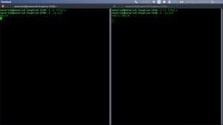
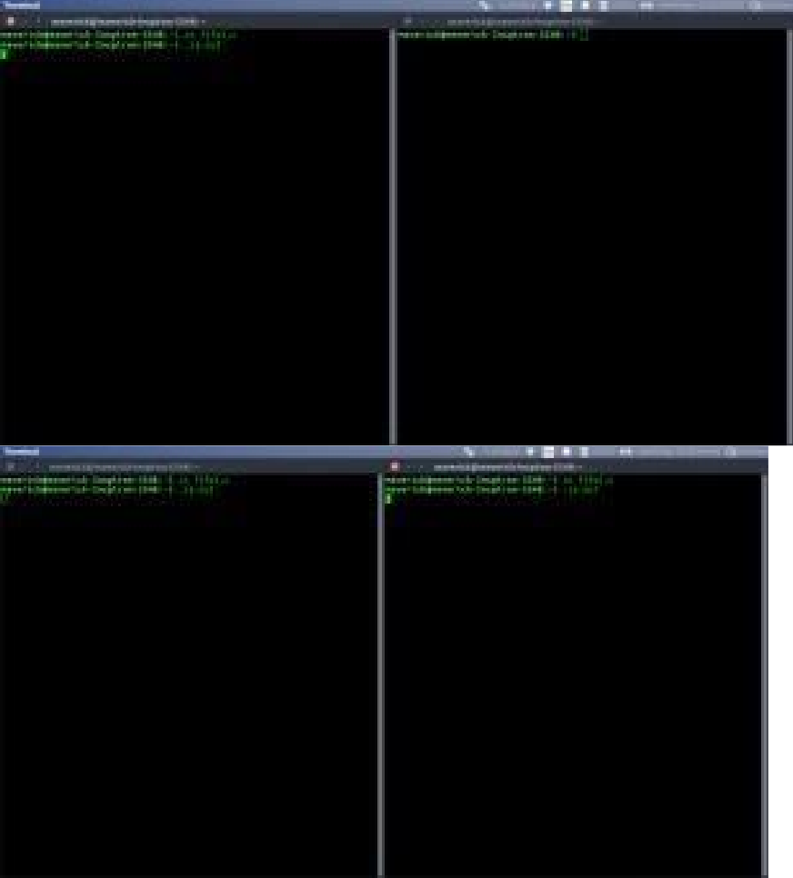

Output:
- WriteaCprogramtoillustratetheMessageQueueIPCmechanism PROGRAM:
//CProgramforMessageQueue(WriterProcess)#include<stdio.h>
#include <sys/ipc.h>#include <sys/msg.h>

//structureformessagequeuestructmesg_buffer{ long mesg_type; char mesg_text[100];
}message;

intmain()
{
key_tkey;intmsgid;

//ftoktogenerateuniquekeykey=ftok("progfile", 65);

//msggetcreatesamessagequeue
//andreturnsidentifier
msgid=msgget(key,0666|IPC_CREAT);message.mesg_type=1; printf("Write Data : "); gets(message.mesg_text);
//msgsndtosend message
msgsnd(msgid,&message,sizeof(message),0);

//displaythemessage
printf("Datasendis:%s\n",message.mesg_text);

return0;
}

//CProgramforMessageQueue(ReaderProcess)#include<stdio.h> #include <sys/ipc.h> #include <sys/msg.h>

//structureformessagequeuestructmesg_buffer{ long mesg_type; char mesg_text[100];
}message;

intmain()
{
key_tkey;intmsgid;

//ftoktogenerateuniquekeykey=ftok("progfile",65);

//msggetcreatesamessagequeue
//andreturnsidentifier
msgid=msgget(key,0666|IPC_CREAT);
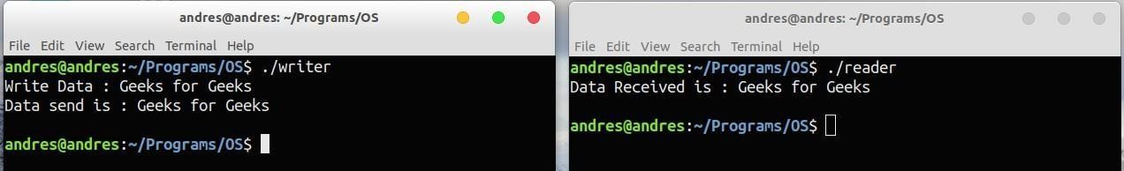
//msgrcvtoreceivemessage
msgrcv(msgid,&message,sizeof(message),1,0);

//displaythemessageprintf("DataReceivedis:%s\n", message.mesg_text);
//todestroythemessagequeuemsgctl(msgid,IPC_RMID,NULL); return 0;
}
Output:

WriteaCprogramto illustratetheSharedMemoryIPCmechanism

PROGRAM:

#include <iostream> #include <sys/ipc.h>#include <sys/shm.h>#include <stdio.h> using namespace std;

intmain()
{
//ftoktogenerateuniquekeykey_tkey=ftok("shmfile",65);

//shmgetreturnsanidentifierinshmid
intshmid= shmget(key,1024,0666|IPC_CREAT);

//shmattoattachtosharedmemory
char*str=(char*)shmat(shmid,(void*)0,0); cout<<"Write Data : "; gets(str); printf("Data written in memory: %s\n",str);
//detachfromsharedmemory shmdt(str);

return0;
}

SHAREDMEMORYFORREADERPROCESS
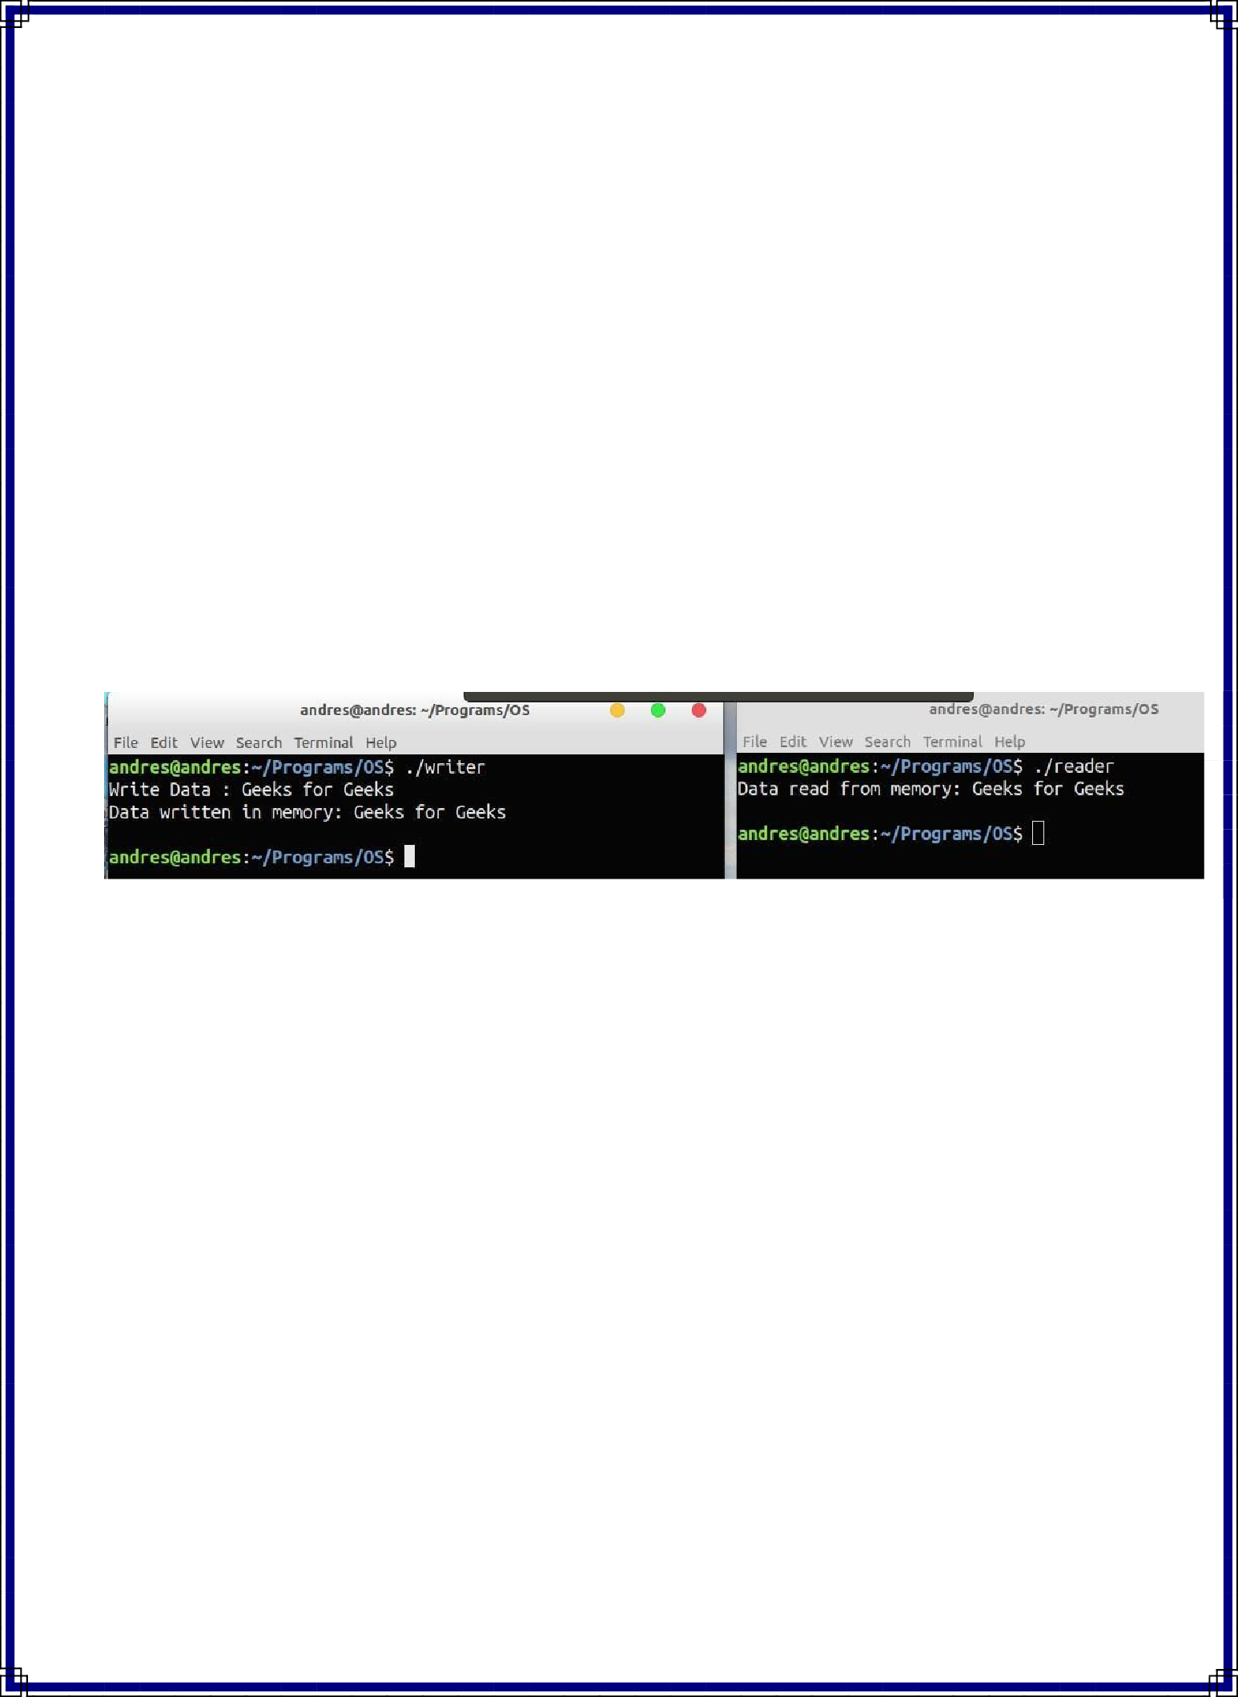
#include<iostream>#include<sys/ipc.h>#include<sys/shm.h>#include<stdio.h>using namespace std;

intmain()
{
//ftoktogenerateuniquekeykey_tkey=ftok("shmfile",65);

//shmgetreturnsanidentifierinshmid
intshmid= shmget(key,1024,0666|IPC_CREAT);

//shmattoattachtosharedmemory
char*str=(char*)shmat(shmid,(void*)0,0);printf("Datareadfrommemory:%s\n",str);
//detachfromsharedmemoryshmdt(str);
//destroythesharedmemoryshmctl(shmid,IPC_RMID,NULL); return 0;
}
Output:
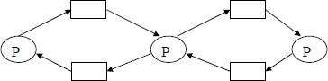
Experiment-3

ImplementBankersAlgorithmforDeadlockAvoidance.
Description:
Deadlock: Aprocessrequesttheresources,theresourcesare notavailableatthattime, so the process enter into the waiting state. The requesting resources are held by another waiting process,bothare in waiting state, this situation is said to be Deadlock.
Adeadlockedsystemmustsatisfiedthefollowing4conditions.Theseare:
- Mutual Exclusion:Mutual Exclusion means resourcesarein non-sharable mode only, it means only one process at a time can use a process.
- Hold and Wait: Each and every process is the deadlock state, must holding at least one resource and is waiting for additional resources, that are currently being held by another process.

- No Preemption:No Preemption means resources are not released in the middle of the work, theyreleased only after the process has completed its task.
- Circular Wait: IfprocessP1 is waiting fora resourceR1, itisheld by P2, processP2 is waitingforR2,R2heldbyP3,P3iswaitingforR4,R4 isheld byP2,P2 waitingforresource R3, it is held by P1.

Deadlock Avoidance: It is one ofthe method of dynamically escapingfrom the deadlocks. In this scheme, if a process request for resources, the avoidance algorithm checks before the allocation of resources about the state of system. If the state is safe, the system allocate the resourcestotherequestingprocessotherwise(unsafe) donotallocatetheresources.Sotaking care before the allocation said to be deadlock avoidance.
Banker’s Algorithm: It isthe deadlock avoidancealgorithm, thename was chosen because the bank never allocates more than the available cash.
Available: Avectoroflength‘m’indicatesthenumber ofavailableresourcesofeachtype.If available[j]=k, there are ‘k’ instances of resource types Rj available.
Allocation:An nxm matrix defines the number ofresourcesof each typecurrentlyallocated to each process. If allocation[i,j]=k, then process Pi is currently allocated ‘k’ instances of resources type Rj.
Max:An nxm matrix defines the maximum demand of each process. If max[i,j]=k, then Pi may request at most ‘k’ instances of resource type Rj.
Need: An nxmmatrix indicatestheremainingresourcesneed ofeach process. Ifneed[I,j]=k, then Pi may need ‘k’ more instances of resource type Rj to complete this task. There fore, Need[i,j]=Max[i,j]-Allocation[I,j]

SafetyAlgorithm:
  - Work and Finish be the vector of length m and n respectively, Work=Available and Finish[i] =False.
  - Findanisuchthatboth
    - Finish[i]=False
    - Need<=Work
IfnosuchIexistsgotostep4.
  - work=work+Allocation,Finish[i]=True;
  - ifFinish[1]=TrueforallI,thenthesystemisin safe state.Resource request algorithm
LetRequestiberequestvectorfortheprocessPi,Ifrequesti=[j]=k,thenprocessPi wants k instances ofresource type Rj.
- ifRequest<=NeedIgotostep2.Otherwiseraiseanerrorcondition.
- ifRequest<=Available go to step 3.Otherwise Pimust sincethe resources are available.
- Have thesystem pretend to have allocated the requested resources toprocess Pi by modifying the state as follows;
Available=Available-Request I; AllocationI=Allocation+RequestI; Need i=Need i-Request I;
Iftheresultingresourceallocation stateissafe, the transactioniscompleted and processPi is allocated itsresources. However, ifthe stateisunsafe, thePi must wait for Request i and the old resource-allocation state is restored.

AlgorithmforBanker’sDeadlockAvoidance:
- Starttheprogram.
- Getthevaluesofresourcesandprocesses.
- Gettheavailvalue.
- Afterallocationfindtheneedvalue.
- Checkwhether itspossibletoallocate.
- Ifitispossiblethenthesystemisinsafestate.
- Elsesystemisnotinsafetystate.
- Ifthenewrequestcomesthencheckthatthesystemisinsafety.
- ornotifweallowtherequest.
- stopthe program.

Program:
#include<stdio.h>#include<conio.h> #include<string.h>void main()
{
int alloc[10][10],max[10][10]; intavail[10],work[10],total[10]; int i,j,k,n,need[10][10];
intm;
intcount=0,c=0; charfinish[10]; clrscr();

printf("Enter the no. of processes and resources:");scanf("%d%d",&n,&m);for(i=0;i<=n;i++)
finish[i]='n';
printf("Entertheclaimmatrix:\n"); for(i=0;i<n;i++)
for(j=0;j<m;j++)
scanf("%d",&max[i][j]); printf("Entertheallocationmatrix:\n"); for(i=0;i<n;i++)
for(j=0;j<m;j++)
scanf("%d",&alloc[i][j]);
printf("Resource vector:"); for(i=0;i<m;i++)
scanf("%d",&total[i]); for(i=0;i<m;i++)
avail[i]=0; for(i=0;i<n;i++)
for(j=0;j<m;j++)
avail[j]+=alloc[i][j]; for(i=0;i<m;i++)
work[i]=avail[i]; for(j=0;j<m;j++)
work[j]=total[j]-work[j]; for(i=0;i<n;i++)
for(j=0;j<m;j++)
need[i][j]=max[i][j]-alloc[i][j]; A:for(i=0;i<n;i++)
{
c=0;
for(j=0;j<m;j++) if((need[i][j]<=work[j])&&(finish[i]=='n'))
c++;
if(c==m)
{
printf("AlltheresourcescanbeallocatedtoProcess%d",
i+1);
printf("\n\nAvailableresourcesare:"); for(k=0;k<m;k++)
{
work[k]+=alloc[i][k];
printf("%4d",work[k]);
}
printf("\n");
finish[i]='y';
printf("\nProcess%dexecuted?:%c\n",i+1,finish[i]); count++;
}
}
if(count!=n)

else
gotoA;

printf("\n System is in safe mode"); printf("\nThegivenstateissafestate");
getch();

OUTPUT1:

Enter theno. of processes and resources: 4 3 Enter the claim matrix:
322
613
314
422
Entertheallocationmatrix:
100
612
211
002
Resourcevector:936
AlltheresourcescanbeallocatedtoProcess2Available resources are: 623
Process2 executed?:y
AlltheresourcescanbeallocatedtoProcess3Avaiable resources are: 834
Process3 executed?:y
AlltheresourcescanbeallocatedtoProcess4Avilableresources are: 8 36
Process4 executed?:y
AlltheresourcescanbeallocatedtoProcess1Aailableresources are: 9 36
Process1executed?:ySystemisinsafemode The given state is safe state
Experiment-4
  - Develop program for PagingTechniqueofMemoryManagementAIM:ToimplementtheMemorymanagementpolicy-Paging.
Description:Pagingisanefficientmemorymanagementschemebecauseitisnon-contiguous memory allocation method.Thebasicideaofpagingisthephysicalmemory(mainmemory)isdividedintofixedsizedblockscalled frames, the logicaladdress spaceisdivided into fixed sized blocks, called pages, but page sizeand frame size should be equal.The size oftheframeora pageisdependingon operatingsystem.
Inthis schemetheoperating systemmaintainsa data structurethatispagetable, itisused formapping purpose. The page table specifies the someuseful information, it tells which framesarethereand soon. The page table consisting oftwo fields, oneisthe page numberand other one isframe number. Everyaddress generated bythe CPUdividedintotwoparts,oneispagenumberandsecondispageoffsetordisplacement.Thepagesareloaded into available free frames in the physical memory.

AlgorithmforPagingTechnique:
Step1:Readallthenecessaryinputfromthekeyboard.
Step2:Pages-Logicalmemoryisbrokenintofixed-sizedblocks.Step3:Frames– Physical memory is broken into fixed – sized blocks.
Step4:Calculate the physical address using the following Physicaladdress=(Framenumber*Framesize)+offset
Step5:Displaythe physicaladdress. Step6:Stopthe process.

/*Programtosimulatepagingtechniqueofmemorymanagement*/
#include<stdio.h>voidmain()
{
intp,ps,i;int*sa;clrscr(); printf("Enterhowmanypages:");scanf("%d",&np);printf("Enterpagesize:");scanf("%d",&ps);for (i=0;i<np;i++)
{
sa[i]=(int)malloc(ps); printf(“Page%daddressis%d\n",i,sa[i]);
}
getch();
}

OUTPUT1:
Enterhowmanypages:5 Enterpage size:4
Page0addressis3080 Page1addressis3088

Page2addressis3096 Page3addressis3104 Page4addressis3112

OUTPUT2:
Enterhowmanypages:7Enterpagesize:8 Page0addressis3080
Page1addressis3096 Page2addressis3112 Page3addressis3128 Page4addressis3144 Page5addressis3160 Page6addressis3176

Experiment-5

Exp.No:5(a)FIFOPAGEREPLACEMENTALGORITHM

AIM:ToimplementFIFO(FirstInFirstOut)pagereplacementalgorithm.

Description:
FIFO (First in First Out) algorithm: FIFO is the simplest page replacement algorithm, theideabehindthisis,“Replaceapagethatpageisoldestpageofmainmemory”or“Replacethe page that has been in memory longest”. FIFO focuses on the length of time a page hasbeeninthememoryratherthanhow muchthe pageisbeingused.

AlgorithmforFIFOPageReplacement:
Step1:Createaqueuetoholdallpagesinmemory
Step2:WhenthepageisrequiredreplacethepageattheheadofthequeueStep3: Nowthenew pageisinsertedatthetailofthequeue

/*ProgramtosimulateFIFOpagereplacement*/

#include<stdio.h>#include<conio.h>Int fr[3],m;
voiddisplay(); voidmain()
{
inti,j,page[20];
int flag1=0,flag2=0,pf=0; intn,top=0;
floatpr; clrscr();
printf("Enterlengthofthereferencestring:");scanf("%d",&n);printf("Enterthereferencestring:");
for(i=0;i<n;i++) scanf("%d",&page[i]);
printf("Enternoofframes:"); scanf("%d",&m); for(i=0;i<m;i++)
fr[i]=-1;for(j=0;j<n;j++)
{
flag1=0;flag2=0; for(i=0;i<m;i++)
{
if(fr[i]==page[j])
{
flag1=1;flag2=1;break;
}
}

if(flag1==0)
{
for(i=0;i<m;i++)
{
if(fr[i]==-1)
{
fr[i]=page[i];flag2=1;break;
}
}
}
if(flag2==0)
{
fr[top]=page[j];top++; pf++;
if(top>=m)
top=0;
}
display();
}
pf+=m;
printf("Number of page faults : %d\n", pf);pr=(float)pf/n*100;
printf("Pagefaultrate=%f\n",pr);getch();
}
voiddisplay()
{
inti;for(i=0;i<m;i++)printf("%d\t", fr[i]);printf("\n");
}

OUTPUT1:
Enterlengthofthereferencestring:12
Enterthereference string:123412512345Enternoofframes:3
1 | -1 | -1
1 | 2 | -1
1 | 2 | 3
4 | 2 | 3
4 | 1 | 3
4 | 1 | 2
5 | 1 | 2
5 | 1 | 2
5 | 1 | 2
5 | 3 | 2

5 | 3 | 4
5 | 3 | 4
Numberofpagefaults:9Pagefaultrate= 75.000000

OUTPUT2:
Enterlengthofthereferencestring:12
Enterthereference string:123412512345Enternoofframes:4
1 | -1 | -1 | -1
1 | 2 | -1 | -1
1 | 2 | 3 | -1
1 | 2 | 3 | 4
1 | 2 | 3 | 4
1 | 2 | 3 | 4
5 | 2 | 3 | 4
5 | 1 | 3 | 4
5 | 1 | 2 | 4
5 | 1 | 2 | 3
4 | 1 | 2 | 3
4 | 5 | 2 | 3
Numberofpagefaults:10Pagefaultrate= 83.333336

OUTPUT3:
Enterlengthofthereferencestring:20
Enterthereferencestring:70120304230321201701Enternoofframes:3
7 | -1 | -1
7 | 0 | -1
7 | 0 | 1
2 | 0 | 1
2 | 0 | 1
2 | 3 | 1
2 | 3 | 0
4 | 3 | 0
4 | 2 | 0
4 | 2 | 3
0 | 2 | 3
0 | 2 | 3
0 | 2 | 3
0 | 1 | 3
0 | 1 | 2
0 | 1 | 2
0 | 1 | 2
7 | 1 | 2
7 | 0 | 2
7 | 0 | 1

Number of page faults : 15Pagefaultrate=75.000000

OUTPUT4:
Enterlengthofthereferencestring:20
Enterthereferencestring:70120304230321201701Enternoofframes:4
7 | -1 | -1 | -1
7 | 0 | -1 | -1
7 | 0 | 1 | -1
7 | 0 | 1 | 2
7 | 0 | 1 | 2
3 | 0 | 1 | 2
3 | 0 | 1 | 2
3 | 4 | 1 | 2
3 | 4 | 1 | 2
3 | 4 | 1 | 2
3 | 4 | 0 | 2
3 | 4 | 0 | 2
3 | 4 | 0 | 2
3 | 4 | 0 | 1
2 | 4 | 0 | 1
2 | 4 | 0 | 1
2 | 4 | 0 | 1
2 | 7 | 0 | 1
2 | 7 | 0 | 1
2 | 7 | 0 | 1
Number of page faults : 10Pagefaultrate=50.000000

Exp.No:5(b)LRUPAGEREPLACEMENTALGORITHM

AIM:ToimplementpagereplacementalgorithmLRU(LeastRecentlyUsed)

Description:
LRU (Least Recently Used): the criteria ofthisalgorithm is“Replacea page that has beenused for the longest period of time”. This strategy is the page replacement algorithm lookingbackwardintime,ratherthanforward.

AlgorithmforLRUPageReplacement:
Step1:Createaqueuetoholdallpagesinmemory
Step2:Whenthe pageisrequiredreplacethe pageatthe head ofthe queueStep3:Now the new page is insertedat the tail of the queue
Step4:Createastack
Step5:Whenthepagefaultoccursreplacepagepresentatthebottomofthe stack

/*ProgramtosimulateLRUpagereplacement*/
#include<stdio.h>#include<conio.h>void display(); void main()
{
inti,j,page[20],fs[10],n,m; intindex,k,l,flag1=0,flag2=0,pf=0;intfr[10];float pr; clrscr();
printf("Enterlengthofthereferencestring:");scanf("%d",&n);printf("Enterthereferencestring:"); for(i=0;i<n;i++)
scanf("%d",&page[i]);printf("Enternoofframes:");
scanf("%d",&m); for(i=0;i<m;i++)
fr[i]=-1;for(j=0;j<n;j++)
{
flag1=0; flag2=0;for(i=0;i<m;i++)
{
if(fr[i]==page[j])
{
flag1=1;flag2=1;break;
}
}
if(flag1==0)
{
for(i=0;i<m;i++)
{
if(fr[i]==-1)
{
fr[i]=page[j];flag2=1; break;
}
}
}
if(flag2==0)
{
for(i=0;i<m;i++)fs[i]=0; for(k=j-1,l=1;l<=m;l++,k--)
{
for(i=0;i<m;i++)
{
if(fr[i]==page[k])
fs[i]=1;
}
}
for(i=0;i<m;i++)
{
if(fs[i]==0)index=i;
}
fr[index]=page[j];
pf++;
}
for(i=0;i<m;i++)printf("%d\t",fr[i]); printf("\n");
}
pf+=m;
printf("Number of page faults : %d\n", pf);pr=(float)pf/n*100;
printf("Pagefaultrate=%f\n",pr); getch();
}

OUTPUT1:
Enterlengthofthereferencestring:20
Enterthereferencestring:70120304230321201701Enternoofframes:4
7 | -1 | -1 | -1
7 | 0 | -1 | -1
7 | 0 | 1 | -1
7 | 0 | 1 | 2
7 | 0 | 1 | 2
3 | 0 | 1 | 2
3 | 0 | 1 | 2
3 | 0 | 4 | 2
3 | 0 | 4 | 2
3 | 0 | 4 | 2
3 | 0 | 4 | 2

3 | 0 | 4 | 2
3 | 0 | 4 | 2
3 | 0 | 1 | 2
3 | 0 | 1 | 2
3 | 0 | 1 | 2
3 | 0 | 1 | 2
7 | 0 | 1 | 2
7 | 0 | 1 | 2
7 | 0 | 1 | 2
Number of page faults : 8Pagefaultrate=40.000000

OUTPUT2:
Enterlengthofthereferencestring:20
Enterthereferencestring:70120304230321201701Enternoofframes:3
7 | -1 | -1
7 | 0 | -1
7 | 0 | 1
7 | 0 | 2
7 | 0 | 2
3 | 0 | 2
3 | 0 | 2
3 | 0 | 4
3 | 0 | 2
3 | 0 | 2
3 | 0 | 2
3 | 0 | 2
3 | 0 | 2
3 | 0 | 1
3 | 2 | 1
0 | 2 | 1
0 | 2 | 1
7 | 2 | 1
7 | 0 | 1
7 | 0 | 1
Number of page faults : 12Pagefaultrate=60.000000

OUTPUT3:
Enterlengthofthereferencestring:12
Enterthereference string:123412512345Enternoofframes:3
1 | -1 | -1
1 | 2 | -1
1 | 2 | 3
4 | 2 | 3
1 | 2 | 3
1 | 2 | 3

1 | 2 | 5
1 | 2 | 5
1 | 2 | 5
1 | 2 | 3
1 | 2 | 4
5 | 2 | 4
Number of page faults : 9Pagefaultrate=75.000000

OUTPUT4:
Enterlengthofthereferencestring:12
Enterthereference string:123412512345Enternoofframes:4
1 | -1 | -1 | -1
1 | 2 | -1 | -1
1 | 2 | 3 | -1
1 | 2 | 3 | 4
1 | 2 | 3 | 4
1 | 2 | 3 | 4
1 | 2 | 3 | 4
1 | 2 | 3 | 4
1 | 2 | 3 | 4
1 | 2 | 3 | 4
1 | 2 | 3 | 4
1 | 2 | 3 | 4
Number of page faults : 6Pagefaultrate=50.000000

Exp.No:5(c)OPTIMAL(LFU)PAGEREPLACEMENTALGORITHM

AIM:Toimplementpagereplacementalgorithms Optimal(Thepagewhichisnotusedforlongesttime)

Description:
LFU (Least Frequently Used): The least frequently used algorithm “select a page forreplacement,ifthepagehasnotbeenusedfortheofteninthepast”or“Replacepagethatpagehassmallestcount”for thisalgorithmeachpagemaintainsascounterwhichcountervalueshowstheleastcount,replacethatpage. Thefrequency counteris reseteach timeispageisloaded.

AlgorithmforOptimal(LFU)PageReplacement:
Hereweselectthepagethatwillnotbeusedforthelongestperiodoftime.Step1:Createanarray.
Step2:Whenthepagefaultoccursreplacepagethatwillnotbeusedforthelongestperiodoftime.

/*Programtosimulateoptimalpagereplacement*/ #include<stdio.h>
#include<conio.h>intfr[3],n,m;
voiddisplay(); void main()
{
inti,j,page[20],fs[10]; intmax,found=0,lg[3],index,k,l,flag1=0,flag2=0,pf=0;floatpr;clrscr(); printf("Enterlengthofthereferencestring:");scanf("%d",&n); printf("Enterthereferencestring:"); for(i=0;i<n;i++)
scanf("%d",&page[i]); printf("Enternoofframes:"); scanf("%d",&m); for(i=0;i<m;i++)
fr[i]=-1;
pf=m;for(j=0;j<n;j++)
{
flag1=0;flag2=0;for(i=0;i<m;i++)
{
if(fr[i]==page[j])
{
flag1=1;

flag2=1;break;
}
}
if(flag1==0)
{
for(i=0;i<m;i++)
{
if(fr[i]==-1)
{
fr[i]=page[j];flag2=1; break;
}
}
}
if(flag2==0)
{
for(i=0;i<m;i++)lg[i]=0; for(i=0;i<m;i++)
{
for(k=j+1;k<=n;k++)
{
if(fr[i]==page[k])
{
lg[i]=k-j;break;
}
}
}
found=0;for(i=0;i<m;i++)
{
if(lg[i]==0)
{
index=i;found=1;break;
}
}
if(found==0)
{
max=lg[0];index=0;for(i=0;i<m;i+
+)
{
if(max<lg[i])
{
max=lg[i];

index=i;
}
}
}
fr[index]=page[j];pf++;
}
display();
}
printf("Number of page faults : %d\n", pf);pr=(float)pf/n*100;
printf("Pagefaultrate=%f\n",pr);getch();
}
voiddisplay()
{
inti;for(i=0;i<m;i++)printf("%d\t",fr[i])
;printf("\n");
}

OUTPUT1:
Enterlengthofthereferencestring:12
Enterthereference string:123412512345Enternoofframes:3
1 | -1 | -1
1 | 2 | -1
1 | 2 | 3
1 | 2 | 4
1 | 2 | 4
1 | 2 | 4
1 | 2 | 5
1 | 2 | 5
1 | 2 | 5
3 | 2 | 5
4 | 2 | 5
4 | 2 | 5
Number of page faults : 7Pagefaultrate=58.333332

OUTPUT2:
Enterlengthofthereferencestring:12
Enterthereference string:123412512345Enternoofframes:3
1 | -1 | -1
1 | 2 | -1
1 | 2 | 3
1 | 2 | 4
1 | 2 | 4
1 | 2 | 4
1 | 2 | 5
1 | 2 | 5
1 | 2 | 5
3 | 2 | 5
4 | 2 | 5
4 | 2 | 5
Number of page faults : 7Pagefaultrate=58.333332

OUTPUT3:
Enterlengthofthereferencestring:20
Enterthereferencestring:70120304230321201701Enternoofframes:3
7 | -1 | -1
7 | 0 | -1
7 | 0 | 1
2 | 0 | 1
2 | 0 | 1
2 | 0 | 3
2 | 0 | 3
2 | 4 | 3
2 | 4 | 3
2 | 4 | 3
2 | 0 | 3
2 | 0 | 3
2 | 0 | 3
2 | 0 | 1
2 | 0 | 1
2 | 0 | 1
2 | 0 | 1
7 | 0 | 1
7 | 0 | 1
7 | 0 | 1
Number of page faults : 9Pagefaultrate=45.000000
Experiment-6

Exp.No:6(a)SEQUENTIALFILEALLOCATION

AIM:WriteaCProgramtoimplementSequentialFileAllocationmethod.

Description:
Filesare normally stored on the disks. Sothe main problem is how toallocate space to thosefiles.Sothatdiskspaceisutilizedeffectivelyandfilescanbeaccessedquickly.Threemajorstrategiesofallocatingdiscspaceareinwideuse.Sequential,indexed andlinked.

Sequentialallocation:
Inthisallocationstrategy,eachfileoccupiesa setofcontiguouslyblocksonthedisk.Thisstrategyisbestsuited. For sequentialfiles,thefileallocationtableconsistsofasingleentryforeachfile.It showsthefilenames, staring block ofthe fileand sizeofthefile.Themainproblemofthisstrategyis,itisdifficulttofindthecontiguousfree blocks in the disk andsomefree blockscouldhappenbetweentwofiles.

AlgorithmforSequentialFileAllocation:

Step1:Starttheprogram.
Step2:Getthenumberofmemorypartitionandtheirsizes.
Step3:Getthenumberofprocessesandvaluesofblocksizeforeachprocess.
Step 4: First fit algorithm searches all the entire memory block until a hole which isbigenoughisencountered. Itallocatesthatmemoryblockfortherequestingprocess.
Step5:Best-fitalgorithmsearchesthememoryblocks forthesmallestholewhichcanbe allocatedtorequestingprocessandallocatesif.
Step6:Worstfitalgorithmsearchesthememoryblocksforthelargestholeandallocatesittotheprocess.
Step7:Analysesallthethreememorymanagementtechniquesanddisplaythebestalgorithmwhichutilizesthememoryresourceseffectivelyand efficiently.
Step8:Stoptheprogram.

/*Programtosimulatesequentialfileallocationstrategy*/
#include
<stdio.h>#include<conio.h>voidmain()
{
intf[50],i,st,len,j,c,k,count=0;clrscr(); for(i=0;i<50;i++)f[i]=0;
printf("Files Allocated are : \n");x:count=0; printf(“Enterstartingblockandlengthoffiles:”);scanf("%d%d",&st,&len);for(k=st;k<(st+len);k++)
if(f[k]==0) count++;
if(len==count)
{
for(j=st;j<(st+len);j++)

if(f[j]==0)
{
f[j]=1;
printf("%d\t%d\n",j,f[j]);
}
if(j!=(st+len-1)) printf(”Thefileisallocatedtodisk\n");
}
else
printf(”Thefileisnotallocated\n");
printf("Doyouwanttoentermorefile(Yes-1/No-0)");scanf("%d",&c); if(c==1)goto x;else
exit();
getch();
}

OUTPUT1:
FilesAllocatedare:
Enterstartingblockandlengthoffiles:14314 1
15 1
16 1
Thefileisallocatedtodisk
Do you want to enter more file(Yes - 1/No - 0)1Enterstartingblockandlengthoffiles:141Thefileis notallocated Do you want to enter more file(Yes - 1/No - 0)1Enterstartingblockandlengthoffiles:144Thefileisnotallocated Doyouwanttoenter morefile(Yes-1/No-0)0

OUTPUT2:
FilesAllocatedare:
Enterstartingblockandlengthoffiles:17417 1
18 1
19 1
20 1
Thefileisallocatedtodisk
Doyouwanttoentermorefile(Yes-1/No-0)1Enterstarting block andlengthoffiles: 213
21 1
22 1
23 1
Thefileisallocatedtodisk
Doyouwanttoentermorefile(Yes-1/No-0)1Enterstarting block andlengthoffiles: 194

Thefileisnotallocated
Doyouwanttoentermorefile(Yes-1/No-0)1Enterstarting block andlengthoffiles: 255
25 1
26 1
27 1
28 1
29 1
ThefileisallocatedtodiskDoyouwanttoenter morefile(Yes-1/No-0)0

Exp.No:6(b)INDEXEDFILEALLOCATION

AIM:WriteaCProgramtoimplementIndexedFileAllocationmethod.

Description:
Indexedallocation:
Indexedallocationsupportsbothsequentialanddirectaccessfiles.Thefileindexesarenotphysicallystoredasa part ofthe fileallocation table. Whenever the file size increases, we caneasilyadd some more blocks to the
index.Inthisstrategy,thefileallocationtablecontainsasingleentry foreachfile.Theentryconsistingof oneindex block, theindex blocks havingthe pointerstotheotherblocks.Noexternalfragmentation.

AlgorithmforIndexedFileAllocation:

Step1:Start.
Step 2:Let nbe thesize of thebufferStep3:checkifthere areanyproducer
Step4:if yescheckwhether thebufferisfull Step5:IfnotheproduceritemisstoredinthebufferStep6:Ifthebufferisfull the producer has to wait
Step 7: Check there is any consumer. If yes check whether the buffer is emptyStep8:Ifnotheconsumerconsumesthemfromthebuffer
Step9:Ifthebufferisempty,theconsumer hasto wait. Step10:RepeatcheckingfortheproducerandconsumertillrequiredStep11:Terminatetheprocess
.

/*Programtosimulateindexedfileallocationstrategy*/#include<stdio.h>#include<conio.h>#includ e<stdlib.h>voidmain()
{
intf[50],index[50],i,n,st,len,j,c,k,ind,count=0;clrscr();for(i=0;i<50;i++)
f[i]=0;
x:printf("Entertheindexblock:"); scanf("%d",&ind);
if(f[ind]!=1)
{
printf("Enternoofblocksneededandnooffilesfor theindex%donthedisk:\n",ind);scanf("%d",&n);
}
else
{
printf("%dindexisalreadyallocated\n",ind);gotox;
}
y:count=0;for(i=0;i<n;i++)
{
scanf("%d",&index[i]); if(f[index[i]]==0)count++;
}
if(count==n)
{
for(j=0;j<n;j++)f[index[j]]=1;printf("Allocated\n");printf("File Indexed\n");for(k=0;k<n;k++)
printf("%d >%d:%d\n",ind,index[k],f[index[k]]);
}
else
{
printf("Fileintheindexisalreadyallocated \n"); printf("Enteranotherfileindexed");
gotoy;
}
printf("Doyouwanttoentermorefile(Yes-1/No-0)");scanf("%d",&c); if(c==1)goto x;else
exit(0);
getch();
}

OUTPUT1:
Entertheindexblock:5
Enternoofblocksneededandnooffilesfortheindex5 onthedisk :4 1234
AllocatedFileIndexed5 >1:1
5 >2:1
5 >3:1
5 >4:1
Do you want to enter more file(Yes - 1/No - 0)1Entertheindexblock:4
4indexisalreadyallocated Entertheindex block:6
Enternoofblocksneededandnooffilesfortheindex6 onthedisk :2 78
A5llocatedFileIndexed6 >7:1
6 >8:1
Doyouwanttoentermorefile(Yes-1/No-0)0

OUTPUT2:
Entertheindexblock:4
Enternoofblocksneededandnooffilesfortheindex4 onthedisk :3 123
AllocatedFileIndexed4 >1:1
4 >2:1
4 >3:1
Doyouwanttoentermorefile(Yes-1/No-0)0

Exp.No:6(c)LINKEDFILEALLOCATION
AIM:WriteaCProgramtoimplementLinkedFileAllocationmethod.

Description:Linkedallocation:
Itiseasytoallocatethefiles,becauseallocationisonanindividualblockbasis.Eachblockcontainsapointerto thenext freeblockinthechain.Herealsothefileallocationtableconsistingofasingleentryforeachfile. Using this strategyany free block can be added to achain very easily.Thereisa link between one block toanother block, that’s why it is said tobelinkedallocation.We canavoidthe externalfragmentation.

AlgorithmforLinkedFileAllocation:

Step1:Createaqueuetoholdallpagesinmemory
Step2:WhenthepageisrequiredreplacethepageattheheadofthequeueStep3: Nowthe newpageisinsertedatthetailofthequeue
Step4:Createastack
Step5:WhenthepagefaultoccursreplacepagepresentatthebottomofthestackStep6:Stoptheallocation.

/*Programtosimulatelinkedfileallocation strategy*/ #include<stdio.h>#include<conio.h> #include<stdlib.h>voidmain()
{
intf[50],p,i,st,len,j,c,k,a;clrscr(); for(i=0;i<50;i++)f[i]=0;
printf("Enterhowmanyblocksalreadyallocated:");scanf("%d",&p); printf("Enter blocks already allocated: ");for(i=0;i<p;i++)
{
scanf("%d",&a);f[a]=1;
}
x: printf("Enter index starting block and length: ");scanf("%d%d",&st,&len);
k=len;if(f[st]==0)
{
for(j=st;j<(st+k);j++)
{
if(f[j]==0)
{
f[j]=1;
printf("%d >%d\n",j,f[j]);
}
else
{
printf("%dBlockisalreadyallocated\n",j);k++;
}
}
}
else
printf("%dstarting blockis already allocated\n",st);printf("Doyouwant to enter more file(Yes - 1/No - 0)");scanf("%d",&c);
if(c==1)goto x;else exit(0);
getch();
}

OUTPUT1:
Enter how many blocks already allocated: 3Enterblocksalreadyallocated:135
Enterindexstartingblockandlength:222 >1
3Blockisalreadyallocated4 >1
Doyouwanttoentermrefile(Yes-1/No-0)0

OUTPUT2:
Enter blocks already allocated: 2 4 6 8 10
12Enterindexstartingblockandlength:3103 >1
4Blockisalreadyallocated5 >1
6Blockisalreadyallocated7 >1
8Blockisalreadyallocated9 >1
10Blockisalreadyallocated11 >1
12Blockisalreadyallocated13 >1
14 >1
15>1
16 >1
17>1
Doyouwanttoenter morefile(Yes -1/No-0)1Enter indexstartingblock andlength: 5 1
5startingblockisalreadyallocated Doyouwanttoenter morefile(Yes- 1/No-0)1
Enterindexstartingblockandlength:18218 >1
19 >1
Doyouwanttoentermorefile(Yes-1/No-0)0
MACHINELEARNINGLAB
INTRODUCTIONTONto LAB:

Machine Learning is used anywhere from automating mundane tasks to offering intelligent insights, industries in every sector try to benefit from it. You may already be using a device that utilizes it. For example,a wearablefitnesstracker likeFitbit, oran intelligenthomeassistantlikeGoogleHome.But there are much more examples of ML in use.

- Prediction:Machine learning can also be used in the prediction systems. Considering the loan example, to computethe probabilityofa fault, thesystemwillneed to classifythe available data in groups.
- Image recognition:Machine learning canbeused for facedetectioninanimageaswell.There isa separate category for each person in a database of several people.
- Speech Recognition:Itisthetranslation ofspoken wordsinto thetext.Itis usedinvoicesearches and more. Voice user interfaces include voice dialing, call routing, and appliance control. It can also be used a simple data entryand the preparation ofstructured documents.
- Medicaldiagnoses:MListrainedtorecognizecanceroustissues.
- Financialindustry:andtrading:companiesuseMLinfraudinvestigationsandcreditchecks.

TypesofMachineLearning?

Machinelearningcanbeclassifiedinto3typesofalgorithms

- SupervisedLearning
- UnsupervisedLearning
- ReinforcementLearning

OverviewofSupervisedLearningAlgorithm

InSupervisedlearning,anAIsystemispresentedwithdatawhichislabeled,whichmeansthateachdatatagged with the correct label.
Thegoalistoapproximatethemappingfunctionsowellthatwhenyouhavenewinputdata(x)thatyoucan predict the output variables (Y) for that data.

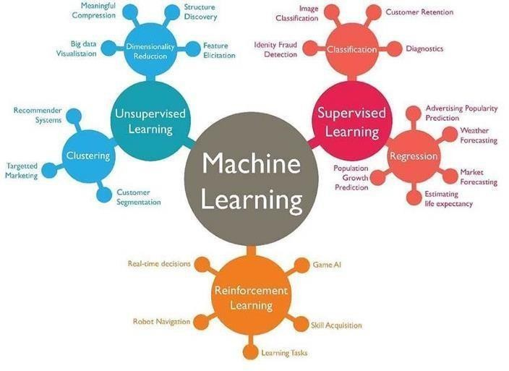
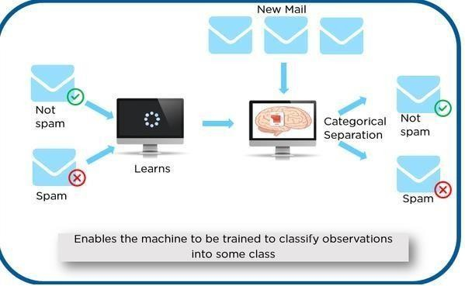

As shown in the above example, we have initially taken some data and marked them as ‘Spam’ or ‘Not Spam’. Thislabeled data isused bythe training supervised model, thisdata isused to trainthe model.

Onceitistrainedwecantest our model bytestingitwithsometestnewmailsandcheckingofthe model isable to predict the right output.

TypesofSupervisedlearning

- Classification:Aclassificationproblemiswhentheoutputvariableisacategory,suchas“red”or“blue” or “disease” and “no disease”.
- Regression:Aregressionproblemiswhentheoutputvariableisarealvalue,suchas“dollars”or
“weight”.

OverviewofUnsupervisedLearningAlgorithm

In unsupervised learning, an AI system is presented with unlabeled, uncategorized data and the system’s algorithms act on the data without prior training. The output is dependent upon the coded algorithms. Subjecting a systemto unsupervised learning is one wayoftesting AI.
TypesofUnsupervisedlearning:

- Clustering:Aclusteringproblemiswhereyouwanttodiscovertheinherentgroupingsinthedata, such as grouping customers by purchasing behavior.
Association:Anassociationrulelearningproblemiswhereyouwanttodiscoverrulesthatdescribelargeportions of your data, such as people that buy X also tend to buyY.

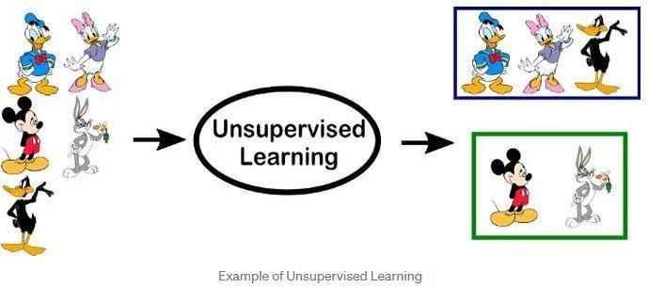

OverviewofReinforcementLearning

A reinforcement learning algorithm, or agent, learns by interacting with its environment. The agent receives rewards by performing correctly and penalties for performing incorrectly. The agent learns without intervention from a human by maximizing its reward and minimizing its penalty. It is a type of dynamic programming that trains algorithms using a systemofreward and punishment.
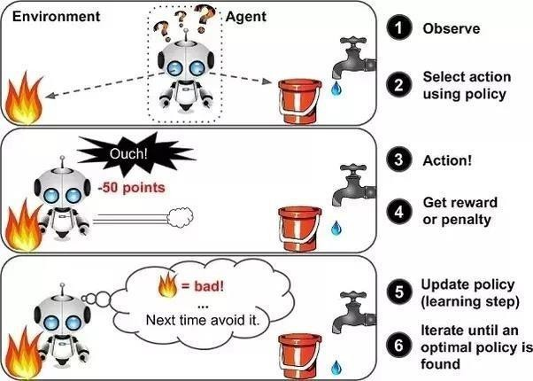

in the aboveexample, wecansee that the agent is given2 options i.e. a pathwithwateror a pathwith fire. A reinforcement algorithm works on reward a system i.e. if the agentuses the fire path then the rewards are subtracted and agent tries to learn that it should avoid the fire path. If it had chosen the water path or the safe path then some points would have beenadded to the reward points, the agent then would try to learn what path is safe and what path isn’t.

Itisbasicallyleveragingtherewardsobtained;the agent improvesitsenvironment knowledgeto selectthe next action.

PROGRAM1(a)
Writeapythonprogramtoimportandexportthedatausing pandaslibrary

ManualFunction
GotoGooglePageandfindwww.kaggle.com.SelectDatasetsandfindTitanicdataset,thendownload train.csv file and save it to desktop.
- Read a CSV file importpandasaspd
url='C:/Users/SNIST/Desktop/train.csv'dataframe=pd.read_csv(url)dataframe.head(5)

- Write a CSVfile Importpandasaspd
marks_data=pd.DataFrame({'ID':{0:23,1:43,2:12,3:13,4:67,5:89},'NAME':{0:'Ram',1
:'Deep',2:'Yash',3:'Arjun',4:'Aditya',5:'Divya'},'Marks':{0:89,1:92,2:45,3:78,4:56,5:76},'Grade':{0:'b',1:'a',2:'f',3:'c',4:'e',5:'c'}})
filename='C:/Users/SNIST/Desktop/Marksdata.xlsx'marks_data.to_excel(filename)
print('DataframewrittentoExcel')

- Read an Excel File import pandas as pdurl='C:/Users/SNIST/Desktop/train.csv.xls'dataframe=pd.read_excel(url)dataframe.head(5)
- Write an Excel file importpandasaspd
marks_data=pd.DataFrame({'ID':{0:23,1:43,2:12,3:13,4:67,5:89},'NAME':{0:'Ram',1
:'Deep',2:'Yash',3:'Arjun',4:'Aditya',5:'Divya'},'Marks':{0:89,1:92,2:45,3:78,4:56,5:76},'Grade':{0
:'b',1:'a',2:'f',3:'c',4:'e',5:'c'}})
filename='C:/Users/SNIST/Desktop/Marksdata.csv'marks_data.to_csv(filename)print('Data frame written to CSV');

Output:

57

PROGRAM1(b)

The probability thatitisFridayandthatastudentisabsentis3%.Sincethereare5school daysinaweek,theprobabilitythatitisFridayis20%.Whatisthe probabilitythatastudent is absent given that todayis Friday? Apply Baye’srule in python to gettheresult. (Ans: 15%)

AIM:TofindtheprobabilitythatastudentisabsentgiventhattodayisFriday.

DESCRIPTION:
Machine learning is a method of data analysis that automates analytical model building of data set. Usingtheimplementedalgorithmsthat iterativelylearnfrom data,machinelearningallowscomputersto findhiddeninsightswithoutbeingexplicitlyprogrammedwheretolook.Naivebayesalgorithmisoneof the most popular machines learning technique. In this article we will look how to implement Naive bayes algorithm using python.
Before someone can understand Bayes’ theorem, they need to know a couple of related concepts first, namely, the idea of Conditional Probability, and Bayes’ Rule.
Conditional Probability isjust what is the probabilitythat something will happen, given that something else has already happened.
Let saywe have a collection ofpeople. Some ofthem are singers. They are either male or female. If we selecta random sample, whatistheprobabilitythatthis personisa male? whatistheprobabilitythatthis person is a male and singer? Conditional Probability is the best option here. We can calculate probability like,
P(Singer &Male)=P(Male)xP(Singer/Male) WhatisBayesrule ?
We cansimplydefine Bayes rule like this. Let A1, A2, …, Anbe a setofmutuallyexclusive eventsthat together form the sample space S. Let B be any event from the same sample space, such that P(B) > 0. Then,P( Ak |B) =P( Ak ∩ B) / P( A1 ∩ B) + P( A2 ∩ B)+. . .+P( An∩B )

58

WhatisBayesclassifier?

NaiveBayesclassifiersarea familyofsimpleprobabilisticclassifiersbased onapplyingBayes’theorem with strong (naive) independence assumptions between the features in machine learning. Basically we can use above theoriesand equations for classification problem.

SOURCECODE:
.Tofindtheprobabilitythata studentisabsentgiventhattodayisFriday,weusetheformula forconditional probability:
P(Absent|Friday)=P(AbsentandFriday)/P(Friday) From the problem:
P(Absent and Friday)=0.03 (3%) P(Friday)=0.20 (20%)
P(Absent|Friday)=0.03/0.20=0.15

So,theprobabilitythatastudentisabsentgiventhattodayisFridayis15%.

ThePythoncodethatimplementsBayes'Ruletocalculatetheconditionalprobabilityofastudentbeing absent given that today is Friday.
defbayes_rule(p_absent_and_friday,p_friday):

returnp_absent_and_friday/p_friday # Given probabilities
p_absent_and_friday=0.03#P(AbsentandFriday) p_friday = 0.20 # P(Friday)
#CalculateP(Absent|Friday)

p_absent_given_friday=bayes_rule(p_absent_and_friday,p_friday)

print("TheprobabilitythatastudentisabsentgiventhattodayisFriday is:", p_absent_given_friday*100,"%")
Output:Theprobabilitythata studentisabsentgiventhattodayisFridayis:15.0%

Output:15

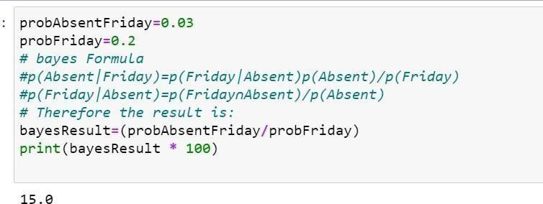

1.5.VIVAQUESTIONS&ANSWERS
- WhatareBayesianNetworks(BN)?

Bayesian Network is used to represent the graphical model for probability relationship among a set of variables. Bayes’ theorem is a way to figure out conditional probability. Conditional probability is the probability of an event happening, given that it has some relationship to one or more other events. For example,yourprobability ofgettinga parkingspace is connected tothetime ofday you park, where you park, and what conventions are going onat anytime. Bayes’ theoremis slightlymore nuanced. Ina nutshell, it gives you the actualprobabilityofan event given information about tests.

- “Events” Are different from “tests.” For example, there is atestfor liver disease, but that’s separate from the event of actually having liver disease.
- Tests are flawed: just because you have a positive test does not mean you actually have the disease.Manytestshaveahighfalsepositiverate.Rareeventstendtohavehigherfalsepositiverates than more common events. We’re not just talking about medical tests here. For example, spam filtering canhave high false positive rates. Bayes’theoremtakesthe test results and calculates yourreal probability that the test has identified the event.
- CanyougiveanyrealtimeexampleusingBayes’Theorem(liverdisease).

You might be interested in finding out a patient’s probability of having liver disease if they are an alcoholic. “Being analcoholic” isthe test (kind oflikea litmus test) for liver disease.

  - Acouldmeantheevent“Patienthasliverdisease.”Pastdatatellsyouthat10%ofpatientsenteringyourclinic have liver disease. P(A) = 0.10.
  - Bcouldmeanthelitmustestthat “Patient isanalcoholic.”Fivepercentoftheclinic’spatientsare alcoholics. P(B) = 0.05.
  - Youmightalsoknowthatamongthosepatientsdiagnosedwithliverdisease,7%arealcoholics. This is your B|A:the probabilitythata patient isalcoholic,giventhattheyhaveliver disease,is7%.
Bayes’theoremtellsyou:

P(A|B)=(0.07*0.1)/0.05=0.14

Inotherwords,ifthepatientisanalcoholic,theirchancesofhavingliverdiseaseis0.14(14%).

This is a large increase from the 10% suggested by past data. But it’s still unlikely that any particular patient has liver disease.

- Bayes’TheoremExamples2:whatistheprobabilitythattheywillbeprescribedpainpills?
Another way to look at the theorem is to say that one event follows another. Above I said “tests” and “events”, but it’s also legitimate to think of it as the “first event” that leads to the “second event.” There’s no oneright wayto dothis: use the terminologythat makes most senseto you.
In a particular pain clinic, 10% of patients are prescribed narcotic pain killers. Overall, five percent of theclinic’spatients areaddictedtonarcotics (includingpainkillersandillegalsubstances).Outofallthe peopleprescribedpainpills,8%areaddicts.Ifapatientisanaddict,whatistheprobabilitythattheywill be prescribed pain pills?
Step 1:Figure outwhatyourevent“A”is fromthe question.That information is inthe italicized part ofthisparticularquestion.Theeventthat happensfirst(A)isbeingprescribedpainpills.That’sgivenas10%.
Step2:Figure outwhatyourevent“B”is fromthe question.That information isalso inthe italicized part ofthis particular question. Event B is being an addict. That’s given as 5%.
Step3:Figureoutwhat theprobabilityof eventB (Step2)giveneventA (Step1).Inother words,find what (B|A) is. We want to know“Giventhat people are prescribed painpills, what’sthe probability theyare an addict?” Thatis given in the question as 8%, or .8.

Step4:InsertyouranswersfromSteps1,2and3intotheformulaandsolve. P(A|B) = P(B|A) * P(A) / P(B) = (0.08 * 0.1)/0.05 = 0.16
Theprobabilityofanaddictbeingprescribedpainpillsis0.16(16%).

- Bayes’TheoremExamples3:theMedicalTestifapersongetsapositivetestresult.
whataretheoddstheyactuallyhavethegeneticdefect?

Aslightlymorecomplicatedexampleinvolvesamedicaltest(inthiscase,agenetictest):

Thereareseveralforms ofBayes’Theorem outthere,andtheyareallequivalent(theyarejust writtenin slightly different ways). In this next equation, “X” is used in place of “B.” In addition,you’ll see some changes in the denominator. The proof of why we can rearrange the equation like this is beyond the scopeofthisarticle(otherwiseit wouldbe5,000 wordsinstead of2,000!). However,ifyou comeacross a question involving medical tests, you’lllikely beusing thisalternative formula to find the answer:

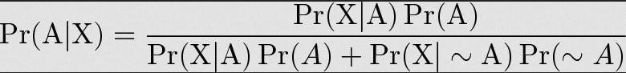

1%ofpeople havea certaingenetic defect. 90%oftestsforthegenedetectthedefect(truepositives).9.6% of the tests are false positives.
Ifapersongetsapositivetestresult,whataretheoddstheyactuallyhavethegeneticdefect?
ThefirststepintosolvingBayes’theoremproblemsistoassignletterstoevents:

- A=chanceofhavingthefaultygene.That wasgiveninthequestionas1%. Thatalsomeanstheprobability of not having the gene (~A) is 99%.
- X=Apositivetestresult.
Sol:

- P(A|X)=Probabilityofhavingthegenegivenapositivetestresult.
- P(X|A)=Chanceofapositivetestresultgiventhatthepersonactuallyhasthegene.Thatwasgivenin the question as 90%.
- p(X|~A)=Chanceofapositivetest ifthepersondoesn’thavethegene.That wasgiveninthequestion as 9.6%
Nowwehavealloftheinformationweneed to put into theequation: P(A|X)=(.9*.01)/(.9*.01+.096*.99)=0.0865(8.65%).

Theprobabilityofhavingthefaultygeneonthetestis8.65%.

- Giventhefollowingstatistics, what istheprobabilitythatawomanhascancerifshehasa positivemammogram result?
- Onepercentofwomenover50havebreastcancer.
- Ninetypercentofwomenwhohavebreastcancertestpositiveonmammograms.
- Eightpercentofwomenwillhavefalsepositives.
Step 1: Assign events to Aor X. Youwant to know what awoman’s probability of having cancer is, givenapositive mammogram.Forthisproblem,actuallyhavingcancer isAandapositivetestresultis X. Step2:Listoutthepartsoftheequation(this makes it easier to worktheactualequation): P(A)=0.01 P(~A)=0.99
P(X|A)=0.9 P(X|~A)=0.08
Step3:Insertthepartsintotheequationandsolve.Notethatasthisisamedicaltest,we’reusingtheformofthe equation from example #2:
(0.9*0.01)/((0.9*0.01)+(0.08*0.99)=0.10.

Theprobabilityofawomanhavingcancer,givenapositivetestresult,is10%.

PROGRAM2

EXTRACTTHEDATAFROMDATABASEUSINGPYTHON

You’lllearnthefollowingMySQL SELECToperations fromPythonusinga ‘MySQLConnector Python’ module.

  - ExecutetheSELECTqueryandprocesstheresultsetreturnedbythequeryinPython.
  - UsePythonvariablesinawhereclauseofaSELECTquerytopassdynamicvalues.
  - Usefetchall(),fetchmany(),andfetchone()methodsofacursorclasstofetchallor limitedrows from atable.
  - PythonSelectfromMySQLTable
ThisarticledemonstrateshowtoselectrowsofaMySQLtableinPython.

You’ll learn the following MySQL SELECT operations from Pythonusing a ‘MySQL Connector Python’ module
.
  - ExecutetheSELECTqueryandprocesstheresultsetreturnedbythequeryinPython.
  - UsePythonvariablesinawhereclauseofaSELECTquerytopassdynamicvalues.
  - Usefetchall(),fetchmany(),andfetchone()methodsofacursorclasstofetchallorlimitedrows fromatable.
  - StepstofetchrowsfromaMySQLdatabasetableFollowthesesteps:–

SOURCECODE:

Step1:CreateaTable(students)inMysqlDatabase(SampleDB)

OpenCommandpromptandthenexecutethefollowingcommandtoenterintoMySQLprompt.

mysql-uroot-p
create database SampleDB; use SampleDB;
CREATE TABLEstudents (sidVARCHAR(10),sname VARCHAR(10),age int); INSERT INTO students VALUES('22311A0521','AAA',23);
INSERTINTOstudentsVALUES('22311A0522','BBB',22); INSERTINTOstudentsVALUES('22311A0523','CCC',25); INSERTINTOstudentsVALUES('22311A0524','DDD',24);

pipinstall mysql.connector
#toconnectwithmysqldatabasethroughpython import mysql.connector
#Createtheconnectionobject
myconn=mysql.connector.connect(host="localhost",user="root",passwd="",database="SampleDB") # Creating the cursor object
cur=myconn.cursor() #Executingthequery
cur.execute("select*fromstudents")
#Fetchingtherowsfromthecursorobject result = cur.fetchall()
print("StudentDetailsare:") # Printing the result
forxinresult: print(x);
#Committhetransaction myconn.commit()
#Closetheconnection myconn.close()

OUTPUT:
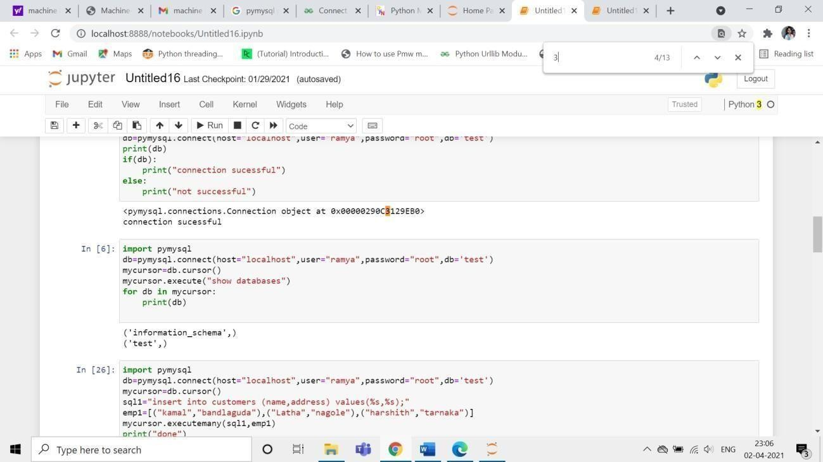

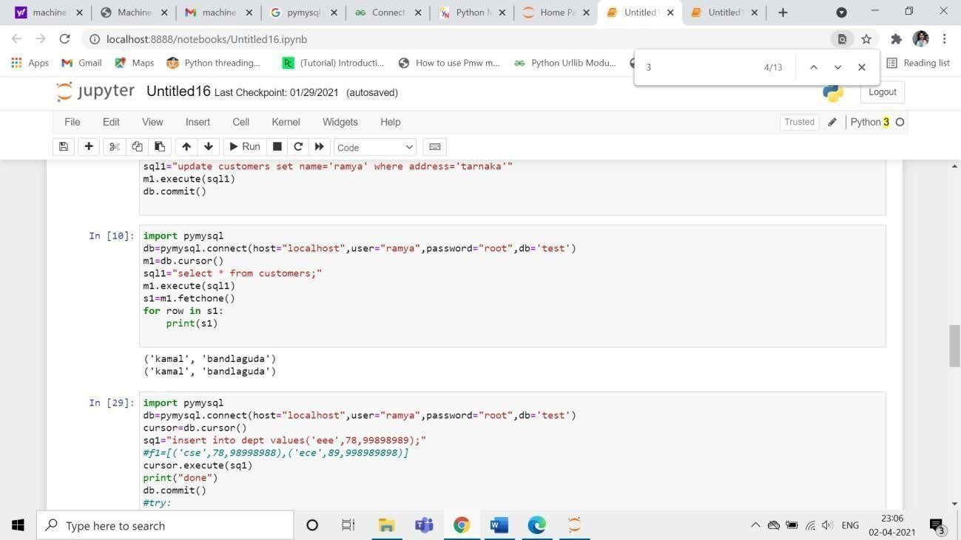

VIVAQUESTIONSANDANSWERS
- HowtoselectfromaMySQLtableusingPython?

ConnecttoMySQLfromPython

RefertoPythonMySQLdatabaseconnectiontoconnect to MySQLdatabase fromPythonusing MySQL Connector module

DefineaSQLSELECTQuery

Next, prepareaSQLSELECT queryto fetchrowsfroma table. You canselect allor limited rowsbased on yourrequirement.If the where conditionisused,thenitdecides the numberof rows tofetch. For example, SELECT col1, col2,…colnN FROM MySQL_table WHEREid = 10;. This will return row number 10.

GetCursorObjectfromConnection

Next,useaconnection.cursor()methodtocreateacursorobject.ThismethodcreatesanewMySQLCursor
object.

Execute the SELECT query using execute() method Executetheselect queryusingthecursor.execute() method. Extract all rows from a result
AftersuccessfullyexecutingaSelectoperation,Usethefetchall()methodofacursorobjecttogetallrows from a queryresult. it returns a list of rows.

Iterateeachrow

Iteratearowlistusingaforloopandaccesseachrowindividually(Accesseachrow’scolumndatausinga column name or index number.)

Closethecursorobjectanddatabaseconnectionobject

usecursor.clsoe()andconnection.clsoe()methodtocloseopenconnectionsafteryourworkcompletes.

- Whatarethemethodstofetchdatareturnedbyacursor.execute()

  - cursor.fetchall()tofetchallrows
  - cursor.fetchone()tofetchasinglerow
  - cursor.fetchmany(SIZE)tofetchlimitedrows
PROGRAM3

IMPLEMENTK-NEARESTNEIGHBORSCLASSIFICATIONUSING PYTHON

AIM:ToImplementk-neighboursclassificationusingpython

DESCRIPTION:

This algorithm is used tosolve the classification model problems.K-nearestneighbororK-NN algorithm basically creates an imaginary boundary to classify the data.Whennew data points comein, the algorithm will try to predict that to the nearest ofthe boundary line.
Therefore,larger k valuemeans smothercurves of separation resultinginlesscomplexmodels. Whereas, smaller k valuetends to over fit the data and resulting in complex models.
It’s very important to have the right k-value when analyzing the dataset to avoid over fitting and under fitting of the dataset.

KNNMODELREPRESENTATION:
ThemodelrepresentationforKNNistheentiretrainingdataset.Itisassimpleasthat. KNNhasno modelotherthanstoringtheentiredataset,sothereisnolearningrequired.
Efficient implementations can storethedata using complex data structures like k-dtreesto make look-up and matching of new patterns during prediction efficient.
Becausetheentiretrainingdataset isstored, you maywant to thinkcarefullyabouttheconsistencyof your trainingdata.Itmightbea goodideatocurateit,updateitoftenasnewdata becomesavailableandremove erroneous and outlier data.
- Thek-nearestneighboralgorithmisimportedfromthescikit-learnpackage.
- Createfeatureandtargetvariables.
- Splitdataintotrainingandtestdata.
- Generateak-NNmodelusingneighborsvalue.
- Trainorfitthedataintothemodel.
- Predictthefuture.

69

SOURCECODE:
pipinstallscikit-learn
ConsideringIrisDataset(70%training setand30%testdataset)
Thefeaturesofirisdatasetsepallength(cm),sepalwidth(cm),petallength(cm),petal width(cm)

#Importnecessarymodules
from sklearn.neighbors import KNeighborsClassifier fromsklearn.model_selectionimporttrain_test_split from sklearn.datasets import load_iris
importrandom

# Loading data data_iris=load_iris()
# To get list of target names label_target = data_iris.target_names print("SampleDatafromIrisDataset") print("*"*30)
#todisplaythesampledatafromtheirisdataset for i in range(10):
rn = random.randint(0,120) print(data_iris.data[rn],"===>",label_target[data_iris.target[rn]])
#Createfeatureandtargetarrays X = data_iris.data
y=data_iris.target

#Splitintotrainingandtestset
X_train,X_test,y_train,y_test=train_test_split(
X,y,test_size=0.3,random_state=1)

print("TheTrainingdatasetlength:",len(X_train)) print("The Testing dataset length: ",len(X_test))

try:

nn=int(input("Enternumberofneighbors:")) knn = KNeighborsClassifier(nn)

knn.fit(X_train, y_train) # to display the score
print("TheScoreis:",knn.score(X_test,y_test)) # To get test data from the user
test_data=input("EnterTestData:").split(",") for i in range(len(test_data)):
test_data[i]=float(test_data[i])

except:
print()
v = knn.predict([test_data])print("Predicted output is :",label_target[v])

print("Pleasesupplyvalidinput ")

Output:
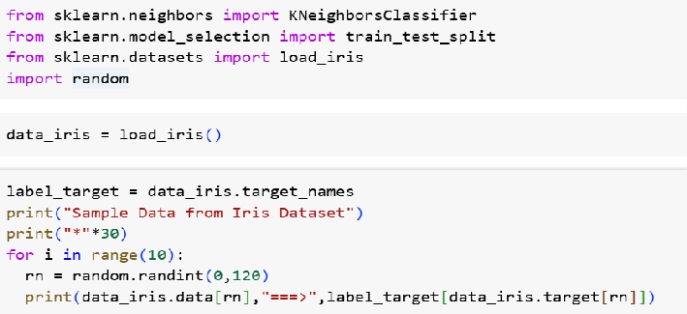

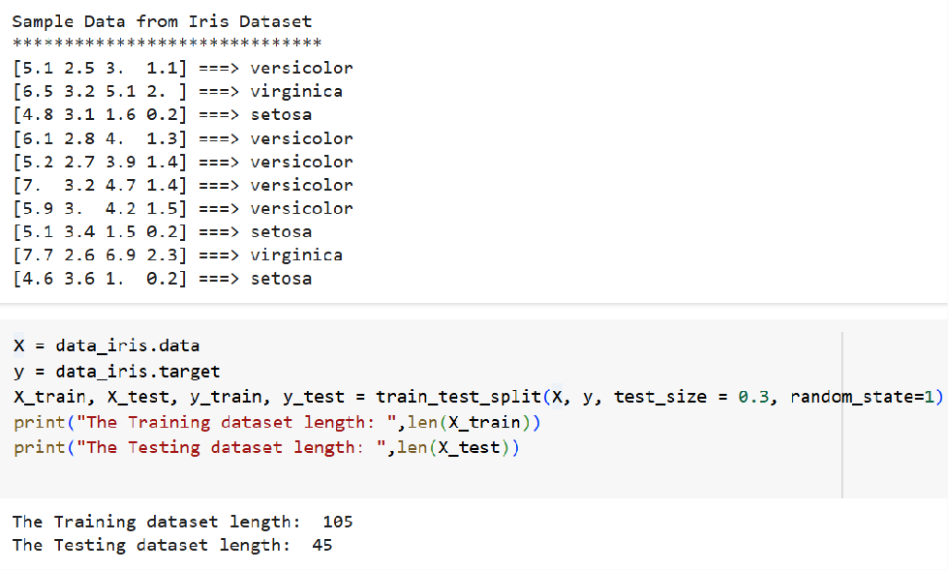
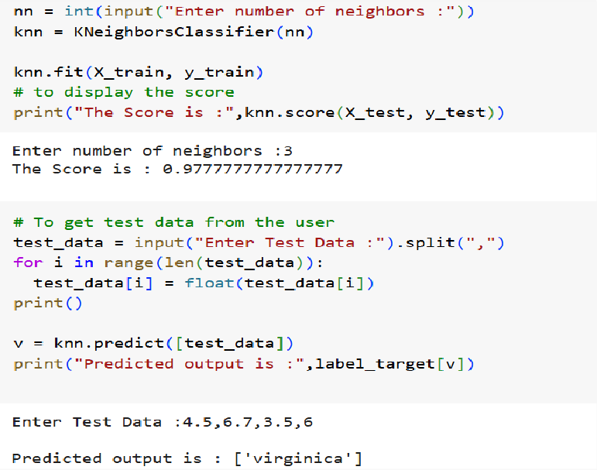
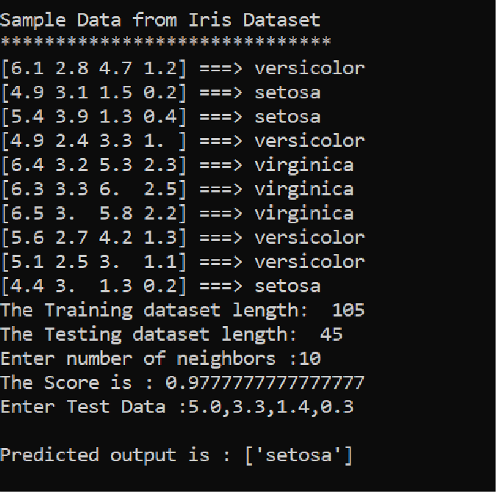

VAQUESTIONS&ANSWERS

- WhatistheKNNAlgorithm?

KNN(K-nearestneighbors)isasupervisedlearningandnon-parametricalgorithmthatcanbeusedtosolve both classification and regression problem statements.
It uses data in which there is a target column presenti.e, labeled data to modela function to produce an outputfortheunseendata. ItusestheEuclideandistance formulato computethedistancebetweenthedata points for classification or prediction.

Themainobjectiveofthisalgorithmisthat similar datapoints must becloseto eachothersoit usesthe distance to calculate the similar points that are close to each other.

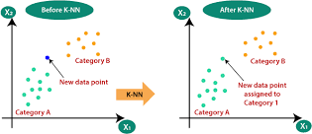

- WhyisKNNanon-parametricAlgorithm?

Theterm“non-parametric”refersto notmakinganyassumptionsontheunderlyingdatadistribution. These methods do not haveany fixed numbers ofparameters inthe model.

SimilarlyinKNN,themodelparametersgrowwiththetrainingdatabyconsideringeachtrainingcaseasa parameter ofthe model. So, KNN is a non-parametric algorithm.

- Whatis“K”intheKNNAlgorithm?

Krepresentsthenumberofnearest neighborsyouwant toselectto predicttheclassofagivenitem, whichis coming as an unseen dataset for the model.

- Whyistheoddvalueof“K”preferredoverevenvaluesintheKNNAlgorithm?

TheoddvalueofKshouldbepreferredoverevenvaluesin ordertoensurethattherearenotiesin the voting.Ifthe squareroot ofa number ofdata points is even,thenadd or subtract 1to it to makeit odd.

- HowdoestheKNNalgorithmmakethepredictionsontheunseendataset?

Thefollowingoperationshavehappenedduringeachiterationofthealgorithm.Foreachoftheunseenortest data point, the kNN classifier must:

Step-1:Calculatethedistancesoftestpointtoallpointsinthetrainingsetandstorethem

Step-2:Sort the calculated distances in increasing order Step-3:StoretheKnearest points fromourtrainingdataset Step-4: Calculate the proportions of each class
Step-5:Assigntheclasswiththehighestproportion

PROGRAM-4
- Given thefollowing data, which specify classifications fornine combinations of VAR1 andVAR2predictaclassificationforacasewhereVAR1=0.906andVAR2=0.606,usingtheresultof k-means clustering with 3 means (i.e., 3centroids)
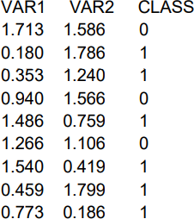

SOURCECODE:
Sol.Weneedapplyk-meansclusteringwith3 means(i.e.,3 centroids)andpredicttheclassfor theVAR1=0.906 and VAR2=0.606
pipinstallscikit-learn
fromsklearn.clusterimportKMeans import numpy as np
X=np.array([[1.713,1.586],[0.180,1.786],[0.353,1.240],
[0.940,1.566],[1.486,0.759],[1.266,1.106],[1.540,0.419],[0.459,1.799],[0.773,0.186]])y=np.array([0,1,1,0,1,0,1,1,1])
kmeans = KMeans(n_clusters=3, random_state=0).fit(X,y) print("The input data is ")
print("VAR1\tVAR2\tCLASS") i=0
forvalinX:
print(val[0],"\t",val[1],"\t",y[i]) i+=1
print("="*20)
# To get test data from the user print("TheTestdatatopredict") test_data = []
VAR1=float(input("EnterValueforVAR1:"))
VAR2=float(input("EnterValueforVAR2:")) test_data.append(VAR1) test_data.append(VAR2)
print("="*20)
print("ThepredictedClassis:",kmeans.predict([test_data]))

Output:
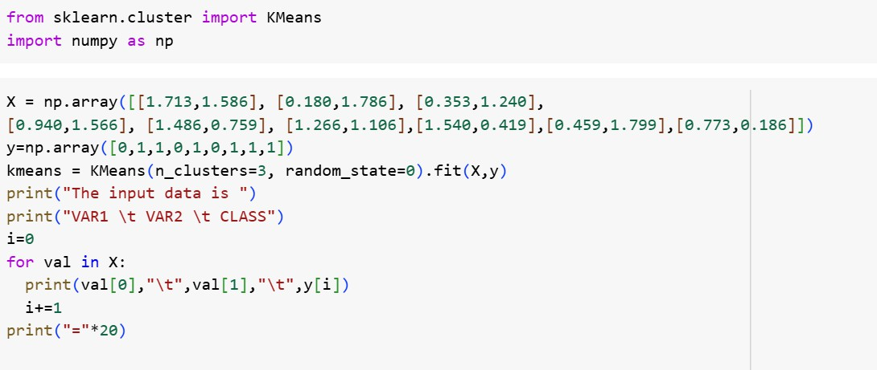
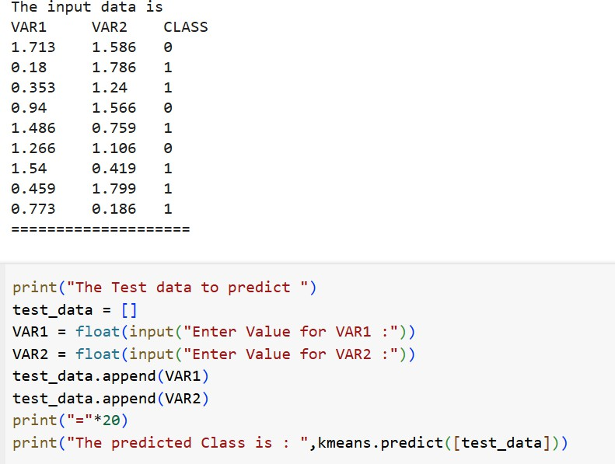
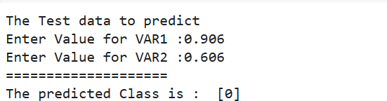

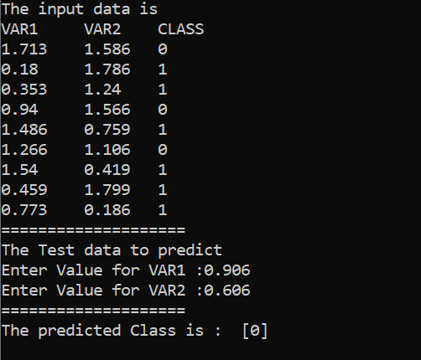

4.3VIVAQUESTIONS&ANSWERS

- WhatisKmeansClusteringAlgorithm?

K Means algorithm is a centroid-based clustering (unsupervised) technique. This technique groups the datasetintok differentclustershavinganalmostequalnumberofpoints.Eachoftheclustershasa centroid point which representsthe mean ofthe data pointslying in that cluster.

The ideaoftheK-Meansalgorithmisto findk-centroidpointsandeverypoint inthedataset willbelong to either of the k-sets having minimum Euclidean distance.

- IsFeatureScalingrequiredfortheKmeansAlgorithm?

Yes, K-Means typically needs to have some form ofnormalization done on the datasets to work properly since it is sensitive to boththe mean and variance ofthe datasets.
Forperforming featurescaling,generally,StandardScalerisrecommended,but dependingonthespecific use cases, other techniques might be more suitable as well.

For Example,let’s have 2 variables, named age and salary where age is in the range of 20 to 60 andsalaryis inthe range of100-150K, since scales of these variables are different so whenthese variables are substituted in the euclidean distance formula, then the variable which is on the large scale suppresses the variable which is onthe smaller scale. So, the impact of age will not be captured veryclearly. Hence, you have to scale the variables to the same rangeusingStandard Scaler,Min-MaxScaler, etc.
- WhichmetricscanyouusetofindtheaccuracyoftheKmeansAlgorithm?

Theredoesnot exist acorrectanswertothisquestionask meansbeing anunsupervised learningtechnique does not discuss anything about the output column. Asa result, one can not get the accuracy number or values from the algorithm directly.

- WhataretheadvantagesanddisadvantagesoftheKmeansAlgorithm?
Advantages:

- Easytounderstandandimplement.
- Computationallyefficientforbothtrainingandprediction.
- Guaranteedconvergence.

Disadvantages:
- Weneedtoprovidethenumberofclustersasaninputvariabletothealgorithm.
- Itisverysensitivetotheinitializationprocess.
- Goodat clusteringwhenwearedealingwithsphericalclustershapes,but it willperformpoorly when dealing with more complicated shapes.
- DuetotheleveragingoftheEuclideandistancefunction,itissensitivetooutliers.

- WhatarethewaystoavoidtheproblemofinitializationsensitivityintheKmeansAlgorithm?

Therearetwowaystoavoidtheproblemofinitializationsensitivity:

- RepeatKmeans:Itbasicallyrepeatsthealgorithmagainandagainalongwithinitializingthe centroidsfollowedbypickinguptheclusterwhichresultsinthesmallintraclusterdistanceandlargeinterclusterdistance.

- KMeans++:Itisasmartcentroidinitializationtechnique.

Amongsttheabovetwotechniques,K-Means++isthebestapproach.

PROGRAM5
- TheFollowing TrainingExamplesMap DescriptionsOfIndividualsOntoHigh,MediumAndLowCredit-Worthiness.
mediumskiingdesignsingletwentiesno ->highRisk high golftrading married forties yes ->lowRisk
lowspeedwaytransportmarriedthirtiesyes->medRisk mediumfootballbankingsinglethirtiesyes->lowRiskhigh flying media married fifties yes ->highRisk
low football security single twenties no ->medRisk medium golf media single thirties yes ->medRisk mediumgolftransportmarriedfortiesyes->lowRisk highskiingbankingsinglethirtiesyes->highRisklow golf unemployed married forties yes ->highRisk

SOURCECODE:

Inputattributesare(fromlefttoright)income,recreation,job,status,age-group,home- owner.Findtheunconditionalprobabilityof`golf'andtheconditionalprobabilityofsingle'given
`medRisk' in thedataset? totalRecords=10 numberGolfRecreation=4
probGolf=numberGolfRecreation/totalRecordsprint("Unconditional probability of golf: ={}".format(probGolf)) #conditional probability of `single' given`medRisk'
# bayes Formula #p(single|medRisk)=p(medRisk|single)p(single)/p(medRisk) #p(medRisk|single)=p(medRisk ∩single)/p(single)
#Thereforetheresultis:
numberMedRiskSingle=2 numberMedRisk=3
probMedRiskSingle=numberMedRiskSingle/totalRecordspr obMedRisk=numberMedRisk/totalRecordsconditionalProba bility=(probMedRiskSingle/probMedRisk) print("ConditionalprobabilityofsinglegivenmedRisk:={}".format(conditionalProbability))

OUTPUT:

Unconditionalprobabilityofgolf:=0.4 ConditionalprobabilityofsinglegivenmedRisk:=0.6666666666666667
ImplementinginCode:

Inthegivendata set,
Thetotalnumber ofrecordsare10.
Thenumberofrecordswhichcontains'golf'are4. Then, the Unconditional probability of golf :
=Thenumberofrecordswhichcontains'golf'/totalnumberofrecords
=4/10
=0.4
TofindtheConditionalprobabilityofsinglegivenmedRisk, LetS : singleMR : medRisk
BythedefinitionofBaye'srule(conditionalprobability),wehave
P(S∣MR)=P(S∩MR)/P(MR)
P(S∩MR) =ThenumberofMedRiskwithSinglerecords/totalnumberof Records
=2/10=0.2
P(MR)=ThenumberofrecordswithMedRisk/totalnumberofRecords
=3/10=0.3
TheConditionalprobabilityofsinglegivenmedRisk
P(S∣MR)=0.2/0.3 =0.66666

Code:

Output:

total_Records=10 numGolfRecords=4
unConditionalprobGolf=numGolfRecords / total_Recordsprint("Unconditional probability of golf: ={}".format(unConditionalprobGolf))#conditional probability of 'single' given 'medRisk'
numMedRiskSingle=2 numMedRisk=3
probMedRiskSingle=numMedRiskSingle/total_RecordsprobMedRisk=numMedRisk/total_Records conditionalProb=(probMedRiskSingle/probMedRisk)
print("ConditionalprobabilityofsinglegivenmedRisk:={}".format(conditionalProb))

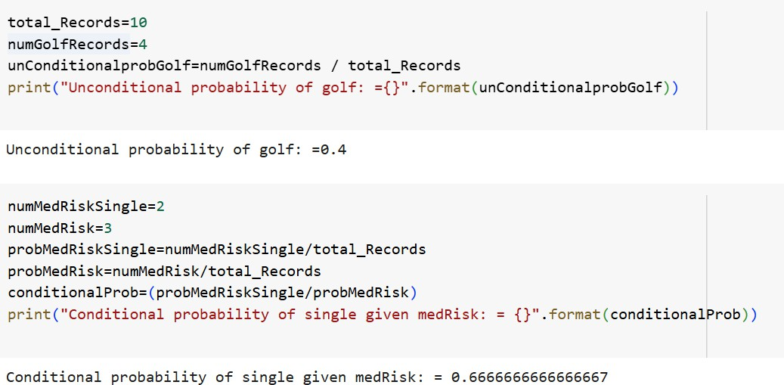

VIVAQUESTIONS&ANSWERS:

- HowKmeans++clusteringAlgorithmworks?

KMeans++algorithmisasmarttechnique forcentroid initializationthat initializedonecentroidwhile ensuringthe othersto be far away fromthe chosen oneresultingin faster convergence.

Thestepstofollowforcentroidinitializationare:

Step-1:Pickthefirstcentroidpointrandomly.

Step-2:Computethedistanceofallpointsinthedataset fromtheselectedcentroid.Thedistanceofx_{i}point fromthe farthest centroid can be calculated bythe given formula:

where,

d_{i}:Distanceofx_{i}pointfromthefarthestcentroidm:numberofcentroidsalreadypicked
Step-3:Makethepointx_{i}asthenewcentroidthatishavingmaximumprobabilityproportionaltod_{i}
Step-4:Repeattheabovelasttwostepstillyoufindkcentroids.

- WhatisthetrainingandtestingcomplexityoftheKmeansAlgorithm?

Trainingcomplexityinterms ofBig-Onotation: IfweuseLloyd’salgorithm,thecomplexityfortrainingis:“K*I*N*M”where,
K:Itrepresentsthenumberofclusters

I:ItrepresentsthenumberofiterationsN:

Itrepresentsthesamplesize

M:Itrepresentsthe numberofvariables Conclusion:ThereisasignificantImpactoncappingthenumberofiterations.Predicting complexityintermsofBig-Onotation:

“K*N*M”

Predictionneedstobecomputedforeachrecord,thedistancetoeachclusterandassignedtothenearestones.

- Isitpossiblethattheassignmentofdatapointstoclustersdoesnotchangebetweensuccessive iterationsinthe K means Algorithm?

WhentheK-Meansalgorithmhasreachedthelocalorglobalminima,itwillnotchangetheassignmentofdata points to clusters for two successive iterations during the algorithmrun.

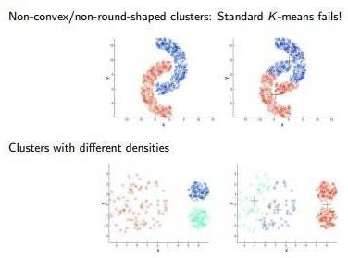

- HowtoChooseKValueinK-Means:

  - Elbowmethod

steps:

step1:computeclusteringalgorithmfordifferentvaluesofk. for example k=[1,2,3,4,5,6,7,8,9,10]
step2:foreachkcalculatethewithin-clustersumofsquares(WCSS).step3:plotcurveofWCSSaccordingtothenumberofclusters.
step4: The location ofbend inthe plot is generally considered an indicator ofthe approximate number of clusters.
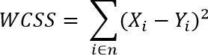
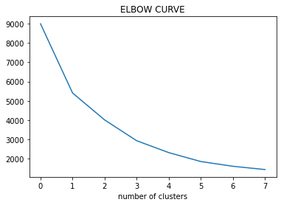

WhatarethepracticalConsiderationsInK-Means:

- AchoosingnumberofClustersinAdvance(K).
- StandardizationofData(scaling).
- CategoricalData(canbesolvedwithK-Mode).
- ImpactofinitialCentroidsandOutliers.

- WhydoyoupreferEuclideandistanceoverManhattandistanceintheKmeansAlgorithm?

EuclideandistanceispreferredoverManhattandistancesinceManhattandistancecalculatesdistanceonly vertically or horizontally due to which it has dimension restrictions.

On the contrary, Euclidean distance can be used in any space to calculate the distances between the data points.SinceinKmeansalgorithmthedata pointscanbe presentinanydimension, soEuclidean distance is a more suitable option.
PROGRAM6:

IMPLEMENTLINEARREGRESSIONUSINGPYTHON.AIM:
ToImplementlinearregressionusingpython.

DESCRIPTION:

Regression:Regressionanalysisisoneofthemostimportantfieldsinstatisticsandmachine learning.There are manyregression methodsavailable. Linear regression is one ofthem
WhatIsRegression?

Regressionanalysisisoneofthe mostimportantfieldsinstatisticsand machine learning.Thereare manyregression methods available. Linear regression isone of
them.Regressionsearchesforrelationshipsamongvariables.Forexample,youcanobserve several employeesofsomecompanyandtrytounderstandhowtheirsalariesdependonthe features,suchasexperience,levelofeducation,role,citytheyworkin,andsoon.Thisisa regressionproblemwheredatarelatedtoeachemployeerepresentoneobservation.The presumptionisthattheexperience,education,role,andcityaretheindependentfeatures, while the salarydependsonthem.Generally, in regressionanalysis, you usuallyconsider some phenomenonofinterestandTherehaveanumberofobservations.Eachobservationhastwoor more features. Following the assumption that(atleast)oneofthefeaturesdependsontheothers,youtrytoestablisharelationamongthem.youneedto findafunctionthatmapssomefeaturesorvariablesto otherssufficiently well.Thedependent featuresarecalled thedependentvariables, outputs,orresponses.The independentfeatures are called the independent variables, inputs, or predictors.

LinearRegression:

Linear regression is probably one of the most important and widely used regression techniques. It’s among the simplest regression methods. One of its main advantages is the easeofinterpretingresults.When implementing linear regressionofsome dependent variable
𝑦on the set of independent variables x= (x₁…x_{rᵣ}),where ris the number of predictors, you assume a linear relationship between y andx: y= β₀+ β₁x₁+ ……+ β_{r}x_{r}+ ϵ. This equation is theregressionequation.β_{0,},β_{r}ᵣaretheregressioncoefficients,and𝜀istherandomerror.
Linear regression calculates the estimatorsof the regression coefficients or simply the predicted weights,denotedwithb₁…b_{r}.Theydefinetheestimatedregressionfunctionf(x)=b0+b₁x₁+
….+b_{r}x_{r}Thisfunctionshouldcapturethedependenciesbetweentheinputsandoutputsufficiently well.

SimpleLinearRegression Thefollowingfigureillustratessimplelinearregression:
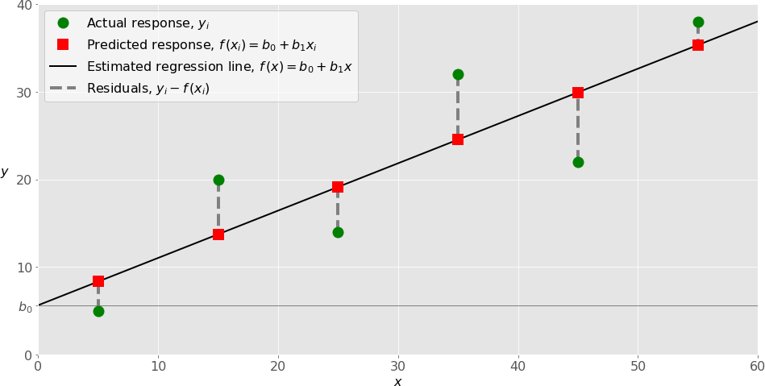

Whenimplementingsimple linearregression, youtypicallystart withagivenset ofinput-output (x-y) pairs (green circles). These pairs are your observations. For example, the leftmost observation(greencircle) hasthe input x=5andtheactualoutput(response)y=5.Thenextone has x= 15 and y= 20, and so on.

Theestimatedregressionfunction(blackline)hastheequationf(x)=b₀+b1x.Yourgoalistocalculatetheopti malvaluesofthepredictedweightsb₀andb1thatminimizeSSRanddetermine theestimatedregressionfunction.Thevalueofb₀,alsocalledtheintercept,showsthepointwheretheestimatedregressionlinecrossesthe yaxis.Itisthevalueoftheestimatedresponse f(x)for x=0. Thevalueofb1 determinestheslopeoftheestimated regression line.

The predicted responses (red squares) are the points on the regression line that correspond to the input values. For example, for the input x= 5, the predicted response is f (5) = 8.33 (represented with the leftmost red square).

Theresiduals(verticaldashedgraylines)canbecalculatedasy₁ᵢ-f(x_{1ᵢ})=y₁–b₀–b₁x₁fori=1,
…,n . They are the distances between the green circles and red squares. When you implement linearregression, you are actually trying to minimizethese distancesand makethe red squaresas close to the predefined green circles as possible.
ImplementingLinearRegressioninPython

It’s time to start implementing linear regression in Python. Basically, all you should do is apply the proper packages and their functions and classes.

PythonPackagesforLinearRegression

The packageNumPyis afundamental Pythonscientific package that allowsmany high- performanceoperationsonsingle-andmulti-dimensionalarrays.Italsooffersmanymathematical routines. Of course, it’s opensource.

Thepackagescikit-learnisawidelyusedPythonlibraryformachinelearning,builtontopofNumPy and some other packages. It provides the means for preprocessing data, reducing dimensionality,implementingregression,classification,clustering,andmore.LikeNumPy,scikit-learn is also opensource.

If you want to implement linear regression and need the functionality beyond the scope ofscikit- learn, you should considerstatsmodels. It’s a powerful Python package for the estimation of statistical models, performing tests, and more. It’s open sourceas well.

SimpleLinearRegressionWithscikit-learn

Let’sstartwiththesimplestcase,whichissimplelinearregression.Thereare five basic steps when you’re implementing linear regression:
- Importthepackagesandclassesyouneed.
- Providedatatoworkwithandeventuallydoappropriatetransformations.
- Createaregressionmodelandfititwithexistingdata.
- Checktheresultsofmodelfittingtoknowwhetherthemodelissatisfactory.
- Applythemodelforpredictions.

SOURCECODE:
importnumpy as npimportmatplotlib.pyplotasplt
defestimate_coef(x,y):

#numberofobservations/pointsn=
np.size(x)
#meanofxandyvector
m_x,m_y=np.mean(x),np.mean(y)

#calculatingcross-deviationanddeviationaboutxSS_xy=np.sum(y*x)
- n*m_y*m_x SS_xx=np.sum(x*x)-n*m_x*m_x
#calculatingregressioncoefficientsb_1=
SS_xy/SS_xx b_0=m_y-
b_1*m_xreturn(b_0, b_1)
defplot_regression_line(x,y,b): #plottingtheactualpointsasscatterplotplt.scatter(x, y, color = "m",
marker="o",s=30)

#predictedresponsevectory_pred= b[0] + b[1]*x

# plotting the regression line plt.plot(x,y_pred,color="g")

#puttinglabels plt.xlabel('x')
plt.ylabel('y')
#functiontoshowplot plt.show() defmain():
#observations

x=np.array([0,1,2,3,4,5,6,7,8,9])

y=np.array([1,3,2,5,7,8,8,9,10,12])

#estimatingcoefficientsb= estimate_coef(x, y) print("Estimatedcoefficients:\nb_0={}\
\nb_1={}".format(b[0],b[1]))

#plottingregressionline plot_regression_line(x,y,b)

ifname =="main": main()

OUTPUT:

Estimatedcoefficients: b_0=-0.05862068965

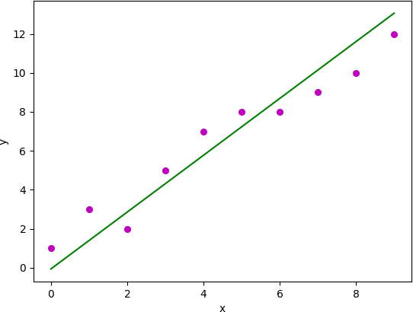

VIVAQUESTIONSANDANSWERS

- WhatdoyoumeanbytheLogisticRegression?

It’s a classification algorithm that is used where the target variable is of categorical nature. The main objective behind Logistic Regression isto determinethe relationship betweenfeaturesand the probability of a particular outcome.
For Example, when weneed to predict whethera student passesor failsin an examgiven the number of hours spent studyingasa feature, the target variable comprisestwo values i.e. passand fail.

Therefore, we can solve classification problem statements which is a supervised machine learning technique using Logistic Regression.

- WhatarethedifferenttypesofLogisticRegression?

ThreedifferenttypesofLogisticRegressionareasfollows:

- BinaryLogisticRegression:Inthis,thetargetvariablehasonlytwo2possibleoutcomes.

ForExample,0and1,orpassandfailortrueandfalse.

- MultinomialLogisticRegression:Inthis, thetargetvariablecanhavethreeormorepossiblevalueswithout any order.
ForExample,Predictingpreferenceoffoodi.e.Veg,Non-Veg,Vegan.
- OrdinalLogisticRegression:Inthis,thetargetvariablecanhavethreeormorevalueswithordering.

ForExample,Movieratingfrom1to5.

- HowdowehandlecategoricalvariablesinLogisticRegression?

The inputs given to a Logistic Regression model need to be numeric. The algorithm cannot handle categorical variables directly. So, we need to convert the categorical data into a numerical format that is suitable for the algorithm to process.

Each level of the categorical variable will be assigned a unique numeric value also known as adummy variable.Thesedummy variablesarehandled bytheLogisticRegressionmodelinthesamemannerasany other numeric value.

- WhataretheassumptionsmadeinLogisticRegression?

SomeoftheassumptionsofLogisticRegressionareasfollows:

- Itassumesthatthereisminimalornomulticollinearityamongtheindependent variablesi.e,predictors are not correlated.
- Thereshouldbealinearrelationshipbetweenthelogitoftheoutcomeandeachpredictorvariable.Thelogitfunctionisdescribedas logit(p)=log(p/(1-p)),wherepistheprobabilityofthetargetoutcome.
- Sometimestopredictproperly,itusuallyrequiresalargesamplesize.

- TheLogisticRegressionwhichhasbinaryclassificationi.e,twoclassesassumethatthetargetvariableisbinary, and ordered Logistic Regression requires the target variable to be ordered.
Forexample,TooLittle,AboutRight,TooMuch.

- Itassumesthereisnodependencybetweentheobservations.

- CanwesolvethemulticlassclassificationproblemsusingLogisticRegression?IfYesthenHow?

Yes, inorderto dealwith multiclassclassificationusing Logistic Regression,the most famous method is knownastheone-vs-allapproach.Inthisapproach,anumberofmodelsaretrained,whichisequaltothenumberof classes. These models work in a specific way.
ForExample,the first modelclassifies the data point depending onwhether it belongs to class 1 orsome otherclass(notclass1);thesecond modelclassifiesthedatapoint into class2orsomeotherclass(not class 2) and so-onfor allother classes. So, inthis manner, eachdatapoint can be checked over allthe classes.

PROGRAM7

IMPLEMENTNAÏVEBAYESTHEOREMTOCLASSIFYTHEENGLISHTEXTAIM:
ToImplementnaïvebaye’stheoremtoclassifytheEnglishtext

DESCRIPTION:
The challenge oftext classification is to attach labels to bodies oftext, e.g., tax document, medical form, etc. based on the text itself. For example, think of your spam folder in your email. How does your email provider know that a particular message is spam or “ham” (not spam)? We’ll take a look at one natural language processing technique for text classification called Naive Bayes

SOURCECODE:
importpandasaspd

fromsklearn.model_selection import train_test_splitfromsklearn.feature_extraction.text import CountVectorizerfrom sklearn.naive_bayes import MultinomialNB
fromsklearn.metricsimportaccuracy_score,confusion_matrix,precision_score,recall_score

msg=pd.read_csv('document.csv',names=['message','label']) print("Total Instances of Dataset: ", msg.shape[0]) msg['labelnum'] = msg.label.map({'pos': 1, 'neg': 0})
X=msg.message y=msg.labelnum
Xtrain,Xtest,ytrain,ytest=train_test_split(X,y)count_v = CountVectorizer()

Xtrain_dm= count_v.fit_transform(Xtrain) Xtest_dm = count_v.transform(Xtest)
df=pd.DataFrame(Xtrain_dm.toarray(),columns=count_v.get_feature_names())

clf = MultinomialNB() clf.fit(Xtrain_dm, ytrain) pred=clf.predict(Xtest_dm)
print('AccuracyMetrics:')

print('Accuracy:',accuracy_score(ytest,pred))print('Recall:',recall_score(ytest,pred))print('Precision:',precision_score(ytest, pred))
print('ConfusionMatrix:\n',confusion_matrix(ytest,pred))

document.csv:

Ilovethissandwich,posThisis an amazingplace,pos
Ifeelverygoodaboutthesebeers,pos This is my best work,pos Whatanawesomeview,pos Idonotlikethisrestaurant,neg I am tired of this stuff,neg Ican'tdealwiththis,negHe ismyswornenemy,negMy
bossishorrible,neg Thisisanawesomeplace,pos
Ido notlikethetasteofthisjuice,negI love to dance,pos Iamsickandtiredofthisplace,negWhat a great holiday,pos
Thatisabadlocalitytostay,neg Wewillhavegoodfuntomorrow,posIwent
tomyenemy'shousetoday,neg

OUTPUT:

TotalInstancesofDataset:18 AccuracyMetrics:Accuracy:0.6 Recall:0.6666666666666666 Precision:0.6666666666666666
ConfusionMatrix: [[1 1]
[12]]

VIVAQUESTIONS&ANSWERS
- HowNaiveBayesalgorithmworks?

Let’sunderstand it using anexample. Below I have atraining datasetofweather and corresponding target variable ‘Play’ (suggesting possibilities ofplaying). Now, weneed to classifywhether players willplayor not based onweather condition. Let’s followthe below stepsto perform it.

Step1:Convertthedatasetintoafrequencytable

Step2:CreateLikelihoodtablebyfindingtheprobabilitieslikeOvercast probability=0.29and probability of playing is 0.64.
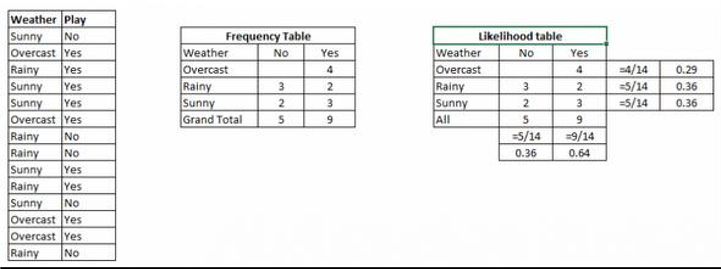
Step3:Now,useNaiveBayesianequationtocalculatetheposteriorprobabilityforeachclass.Theclasswiththe highest posterior probability is the outcome of prediction.

Problem:Playerswillplayifweatherissunny.Isthisstatementiscorrect?We can solve it using above discussed method ofposterior probability.
P(Yes|Sunny)=P(Sunny|Yes)*P(Yes)/P(Sunny)

HerewehaveP(Sunny|Yes)=3/9=0.33,P(Sunny)=5/14=0.36,P(Yes)=9/14=0.64Now,P (Yes | Sunny) = 0.33 *0.64 / 0.36 = 0.60, which has higher probability.
NaiveBayesusesasimilarmethodtopredicttheprobabilityofdifferentclassbasedonvariousattributes.This algorithmis mostlyused intext classification and withproblems having multiple classes.
- ApplicationsofNaiveBayesAlgorithms

  - Real time Prediction: Naive Bayes isan eager learning classifier and itissurefast. Thus, it could be used for making predictions in real time.
  - MulticlassPrediction: Thisalgorithmisalsowellknown formulticlasspredictionfeature.Herewe can predict the probabilityof multiple classes of target variable.
  - Textclassification/ Spam Filtering/SentimentAnalysis:NaiveBayes classifiersmostly usedintext classification(due to better result in multiclass problems and independence rule) have higher success rateascomparedtootheralgorithms.Asaresult,itiswidelyusedinSpamfiltering(identifyspame-mail)and Sentiment Analysis (insocial media analysis,to identifypositive and negativecustomer sentiments)
  - Recommendation System:Naive Bayes Classifier andCollaborative Filtering together builds a Recommendation System that uses machine learning and data mining techniques to filter unseen information and predict whether a user wouldlike a given resource or not

PROGRAM8

IMPLEMENTANALGORITHMTODEMONSTRATETHESIGNIFICANCEOF GENETICALGORITHM

AIM:

ToImplementanalgorithmtodemonstratethesignificanceofgeneticalgorithm

DESCRIPTION:

Genetic Algorithms (GAs) are adaptive heuristic search algorithms that belong to the larger part of evolutionary algorithms. Genetic algorithms are based on the ideas of natural selection and genetics. These are intelligent exploitation of random search provided with historicaldata to direct the search into the region of better performance in solution space. They are commonly used to generate high-quality solutions for optimization problems and search problems.Genetic algorithms simulate the process of natural selection which means those specieswho canadapt tochanges intheir environment areableto surviveandreproduceandgo to next generation. In simple words, they simulate “survival of the fittest” among individual of consecutive generation for solving a problem. Each generation consist of a population of individuals and each individual represents a point in search space and possible solution. Each individualisrepresentedasa string ofcharacter/integer/float/bits.This stringisanalogoustothe Chromosome.Genetic algorithms are based on an analogy with genetic structure and behavior of chromosome of the population. Following isthe foundation of GAs based onthisanalogy –
  - Individualinpopulationcompeteforresourcesandmate
  - Thoseindividualswhoaresuccessful(fittest)thenmatetocreatemoreoffspringthan others
  - Genesfrom“fittest”parent propagatethroughoutthegeneration,that issometimesparents create offspring which is better than either parent.
  - Thuseachsuccessivegenerationismoresuitedfortheirenvironment.
The population of individualsare maintained within search space. Each individualrepresent a solution in search space for given problem. Each individual is coded as a finite length vector(analogoustochromosome)ofcomponents.Thesevariablecomponentsare

analogoustoGenes.Thusachromosome(individual)iscomposedofseveralgenes(variablecomponents)

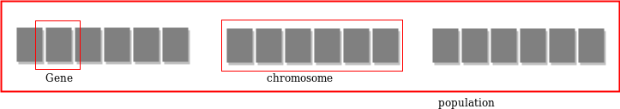

A Fitness Score is given to each individual whichshows the ability ofanindividual to “compete”. The individual having optimal fitness score (or near optimal) are sought.The GAs maintainsthe population of n individuals(chromosome/solutions) along with their fitness scores.The individuals having better fitness scores are given more chance to reproduce than others. The individuals with better fitness scores are selected who mate and producebetter offspring by combining chromosomesof parents.Thepopulation sizeis static so theroom has to be created for new arrivals. So, someindividuals die and get replacedby new arrivals eventually creating new generation when all the mating opportunity of the old population is exhausted.It ishopedthat over successive generationsbetter solutionswillarrive while least fit die.Each new generation has on average more “better genes” than the individual (solution)of previousgenerations.Thuseachnewgenerationshavebetter“partial solutions”than previous generations. Once the offsprings produced having no significant difference than offspring produced by previous populations, the population is converged. The algorithm is said to be converged to a set ofsolutions for the problem.

OPERATORSOFGENETICALGORITHM:
Oncetheinitialgenerationiscreated,thealgorithmevolvethegenerationusingfollowingoperators–
- SelectionOperator: The idea istogivepreferencetothe individualswithgoodfitnessscores and allow themto pass there genes to the successive generations.
- Crossover Operator: This represents mating between individuals. Twoindividuals are selectedusingselectionoperatorandcrossoversitesarechosenrandomly.Thenthegenes atthesecrossoversitesareexchangedthuscreatingacompletelynewindividual(offspring).For example –

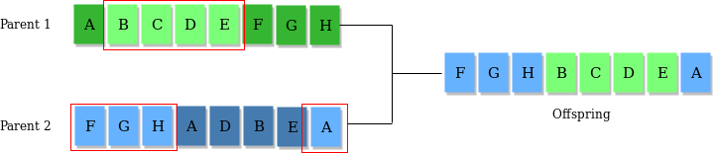

MutationOperator:Thekeyideaistoinsertrandomgenesinoffspringtomaintainthediversityin population to avoid the premature convergence. For example –
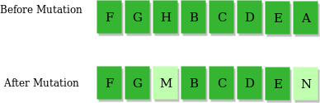

ALGORITHM:
- Randomlyinitializepopulationsp
- Determinefitnessofpopulation
- Untillconvergencerepeat:
  - Selectparentsfrompopulation
  - Crossoverandgeneratenewpopulation
  - Performmutationonnewpopulation
  - Calculatefitnessfornewpopulation

USESOFGENETICALGORITHM:
- TheyareRobust
- Provideoptimisationoverlargespacestate.
- UnliketraditionalAI,theydonotbreakonslightchangeininputorpresenceofnoise

SOURCECODE:

importnumpydefcal_pop_fitness(equation
_inputs,pop): #Calculatingthefitnessvalueofeachsolutioninthecurrentpopulation.
#Thefitnessfunctioncalulatesthesumofproductsbetweeneachinputanditscorresponding weight.
fitness=numpy.sum(pop*equation_inputs,axis=1) return fitness
defselect_mating_pool(pop,fitness,num_parents):

#Selectingthebest individuals inthecurrent generationasparentsforproducingthe offspring of the next generation.
parents=numpy.empty((num_parents, pop.shape[1])) for parent_num in range(num_parents): max_fitness_idx=numpy.where(fitness== numpy.max(fitness)) max_fitness_idx = max_fitness_idx[0][0]parents[parent_num,
:] = pop[max_fitness_idx, :] fitness[max_fitness_idx] = -99999999999
returnparents
def crossover(parents, offspring_size): offspring = numpy.empty(offspring_size)

#Thepointatwhichcrossovertakesplacebetweentwoparents.Usually,itisatthecenter.crossover_point= numpy.uint8(offspring_size[1]/2)
forkinrange(offspring_size[0]):

#Indexofthefirst parentto mate. parent1_idx = k%parents.shape[0]
# Index of the second parent to mate. parent2_idx=(k+1)%parents.shape[0]
#Thenewoffspringwillhaveitsfirst halfofitsgenestakenfromthe firstparent. offspring[k, 0:crossover_point] = parents[parent1_idx, 0:crossover_point]
#Thenewoffspringwillhave itssecondhalfofits genestakenfromthesecondparent. offspring[k, crossover_point:] = parents[parent2_idx, crossover_point:]
returnoffspring

defmutation(offspring_crossover,num_mutations=1):

mutations_counter=numpy.uint8(offspring_crossover.shape[1]/num_mutations)

#Mutationchangesanumberofgenesasdefined bythe num_mutations argument. The changes are random.
foridx in
range(offspring_crossover.shape[0]): gene_idx = mutations_counter - 1 formutation_numinrange(num_mutations): # The randomvaluetobeaddedtothegene.

random_value=numpy.random.uniform(-1.0,1.0,1)
offspring_crossover[idx, gene_idx] = offspring_crossover[idx, gene_idx] + random_value
gene_idx = gene_idx + mutations_counterreturn offspring_crossover
importnumpy

"""

The y=target is to maximizethis equation ASAP: y = w1x1+w2x2+w3x3+w4x4+w5x5+6wx6 where(x1,x2,x3,x4,x5,x6)=(4,-2,3.5,5,- 11,-4.7)
Whatarethebestvaluesforthe6weightsw1tow6?

Wearegoingtousethegeneticalgorithmforthebestpossiblevaluesafteranumber of generations.
"""
#Inputsoftheequation. equation_inputs=[4,-
2,3.5,5,-11,-4.7]

#Numberoftheweightswearelookingto optimize.num_weights=len(equation_inputs)

"""

Geneticalgorithm parameters:Mating pool size
Populationsize

"""

sol_per_pop=8

num_parents_mating= 4 #Definingthepopulationsize.
pop_size=(sol_per_pop,num_weights)#Thepopulationwillhavesol_per_popchromosome where each chromosome has num_weights genes.
#Creatingthe initialpopulation. new_population=numpy.random.uniform(low=-4.0,high=4.0,size=pop_size) print(new_population)
"""

new_population[0,:]=[2.4,0.7,8,-2,5,1.1]

new_population[1,:]=[-0.4,2.7,5,-1,7,0.1]

new_population[2,:]=[-1,2,2,-3,2,0.9]

new_population[3,:]=[4, 7,12,6.1,1.4,-4]

new_population[4,:]=[3.1,4,0,2.4, 4.8,0] new_population[5,:]=[-2,3,-
7,6,3, 3]"""

best_outputs = [] num_generations= 1000
for generation in range(num_generations):
print("Generation:", generation)
#Measuringthefitnessofeachchromosomeinthe
population.fitness=cal_pop_fitness(equation_inputs,new_population) print("Fitness")
print(fitness) best_outputs.append(numpy.max(numpy.sum(new_population*equation_inputs,
axis=1)))#Thebestresultinthecurrentiteration. print("Bestresult:",numpy.max(numpy.sum(new_population*equation_inputs,axis=1)))

#Selectingthebest parentsinthepopulationfor mating. parents = select_mating_pool(new_population, fitness, num_parents_mating)
print("Parents ")
print(parents) #Generatingnextgenerationusing

crossover.offspring_crossover= crossover(parents,
offspring_size=(pop_size[0]-parents.shape[0],num_weights))

print("Crossover") print(offspring_cr ossover)
#Addingsomevariationstotheoffspringusingmutation. offspring_mutation = mutation(offspring_crossover, num_mutations=2) print("Mutation") print(offspring_mutation)
#Creatingthenewpopulationbasedontheparentsandoffspring. new_population[0:parents.shape[0], :] = parents new_population[parents.shape[0]:, :] = offspring_mutation
#Gettingthebestsolutionafteriteratingfinishingallgenerations. #At first, the fitness is calculated for each solution in the final generation. fitness = cal_pop_fitness(equation_inputs, new_population)
#Thenreturnthe indexofthat solutioncorrespondingtothe best fitness. best_match_idx = numpy.where(fitness == numpy.max(fitness))
print("Bestsolution:",

new_population[best_match_idx,:])print("Best solutionfitness:",fitness[best_match_idx]) importmatplotlib.pyplotmatplotlib.pyplot.plot(b est_outp
uts) matplotlib.pyplot.xlabel("Ite ration") matplotlib.pyplot.ylabel("Fit ness") matplotlib.pyplot.show()

OUTPUT:

[[0.582041412.32880696-2.951302092.570569533.33055238-0.58167871][-1.65052225
3.52263842-2.46577305-1.7005396-3.804802020.29677167][2.6239874-2.01548549-
1.722922953.61090243-1.25604726-2.32647264][-3.451673932.857718253.74655682-
2.017906260.25750106-3.12923247][2.86026334-0.4306777-3.262979561.74863348-
1.93705571-3.18855672][-1.700120890.98685104-1.911920723.91873942-0.09354385
1.43038667][0.31769009-0.872908093.752497852.576579930.588830822.83231871][
3.833149260.33838112-2.49509594-1.507631743.99440509-0.03037715]]

Gen erati on :
0
Fitnes s
[-33.708344139.6777259451.30214363-4.6238336545.91897711-1.566046069.24418172-

45.41084308]
Bestresult:
51.302143629097614
Parents
[[2.6239874-2.01548549-1.722922953.61090243-1.25604726-2.32647264][2.86026334-
0.4306777-3.262979561.74863348-1.93705571-3.18855672][-1.650522253.52263842-
2.46577305-1.7005396-3.804802020.29677167][0.31769009-0.872908093.75249785
2.576579930.588830822.83231871]]

Crossover

[[2.6239874-2.01548549-1.722922951.74863348-1.93705571-3.18855672][2.86026334-
0.4306777-3.26297956-1.7005396-3.804802020.29677167][-1.650522253.52263842-
2.465773052.576579930.588830822.83231871][0.31769009-0.872908093.75249785
3.61090243-1.25604726-2.32647264]]

Mutation

[[2.6239874-2.01548549-1.678966321.74863348-1.93705571-3.97789372][2.86026334-
0.4306777-3.12878279-1.7005396-3.80480202-0.15430324][-1.650522253.52263842-
3.376696012.576579930.588830822.25153466][0.31769009-0.872908092.93428907
3.61090243-1.25604726-2.71597954]]
.
.

.

.

Gener ation: 999
Fitnes
s

[2554.39355622551.723607382549.405839542549.299316292552.24225166
2550.45506206
2547.12995122551.22467397]

Bestresult:
2554.3935561987346
Parents
[[3.17690088e-01-8.72908094e-012.67689952e+021.74863348e+00- 1.93705571e+00-3.37108802e+02][3.17690088e-01-8.72908094e-01
2.67638232e+021.74863348e+00-
1.93705571e+00-3.36689592e+02][3.17690088e-01-8.72908094e-012.67254110e+02
1.74863348e+00-1.93705571e+00-3.36865291e+02][3.17690088e-01-8.72908094e-01
2.67370854e+021.74863348e+00-1.93705571e+00-3.36672197e+02]]

Crossover

[[3.17690088e-01-8.72908094e-012.67689952e+021.74863348e+00-1.93705571e+00 - 3.36689592e+02]
[3.17690088e-01-8.72908094e-012.67638232e+021.74863348e+00

-1.93705571e+00-3.36865291e+02]

[3.17690088e-01-8.72908094e-012.67254110e+021.74863348e+00

-1.93705571e+00-3.36672197e+02]

[3.17690088e-01-8.72908094e-012.67370854e+021.74863348e+00

-1.93705571e+00-3.37108802e+02]]

Mutation

[[3.17690088e-01-8.72908094e-012.68382875e+021.74863348e+00

-1.93705571e+00-3.36222272e+02]

[3.17690088e-01-8.72908094e-012.68456819e+021.74863348e+00

-1.93705571e+00-3.37417363e+02]

[3.17690088e-01-8.72908094e-012.67606746e+021.74863348e+00

-1.93705571e+00-3.36866918e+02]

[3.17690088e-01-8.72908094e-012.67051753e+021.74863348e+00

-1.93705571e+00-3.37331663e+02]]

Bestsolution:[[[3.17690088e-01-8.72908094e-012.68456819e+021.74863348e+00

-1.93705571e+00- 3.37417363e+02]]]

Bestsolutionfitness
:[2558.52782726]
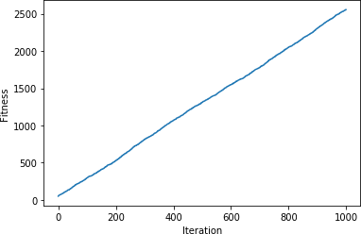

VIVAQUESTIONS&ANSWERS

1.WhatisaGeneticAlgorithm?

Let’sgetbacktotheexamplewediscussedaboveandsummarizewhatwedid.

- Firstly,wedefinedourinitialpopulationasourcountrymen.
- Wedefinedafunctiontoclassifywhetherisapersonisgoodorbad.
- Thenweselectedgoodpeopleformatingtoproducetheiroff-springs.
- Andfinally,theseoff-springsreplacethe badpeople fromthepopulationandthisprocessrepeats.

PROGRAM9

IMPLEMENTTHEFINITEWORDSCLASSIFICATIONSYSTEMUSINGBACK- PROPAGATIONALGORITHM

AIM:

ToimplementthefinitewordsclassificationsystemusingBack-propagationalgorithm

DESCRIPTION:
Whatisbackpropagation?
We can define the backpropagation algorithm as an algorithm that trains some given feed- forward Neural Network for a given inputpattern wherethe classifications are known tous. At the point when every passage ofthe example set is exhibited tothe network,the network looks atitsyieldreactionto the exampleinputpattern. Afterthat,thecomparison done between output response and expected output with the error value is measured.Later,weadjust the connection weight based upon the error value measured.
It was first introduced in the 1960s and 30 years later it was popularized by David Rumelhart,GeoffreyHinton,andRonaldWilliamsinthe famous1986paper.Inthispaper,they spoke about the various neural networks. Today, back propagation is doing good. Neural network training happensthrough back propagation. By thisapproach, wefine-tunethe weights of a neural netbased on the errorrateobtained in the previous run. The rightmanner of applying this technique reduces error rates and makes the model more reliable. Backpropagationis used totrain theneural network of thechain rulemethod.In simple terms,aftereachfeed- forwardpassesthroughanetwork,thisalgorithmdoesthebackward

pass to adjust the model’s parameters based on weights and biases. A typical supervised learning algorithm attempts to find a function that maps input data to the right output. Back propagation works with a multi-layered neural network and learns internal representations of input to output mapping.
The Back propagation algorithm is a supervised learning method for multilayer feed- forward networks from the field of Artificial Neural Networks.
Feed-forward neuralnetworksare inspired bythe informationprocessing ofone or more neural cells, called a neuron. Aneuronaccepts input signals via its dendrites, whichpass the electrical signal down to the cell body. The axon carries the signal out to synapses, which are the connections of a cell’s axon to other cell’s dendrites.
The principle of the backpropagation approach is to model a given function by modifyinginternal weightingsofinput signalstoproduceanexpectedoutputsignal.Thesystem istrainedusinga supervisedlearning method, where the error betweenthe system’s outputand a known expected output is presentedto the systemand usedto modifyits internal state.
Technically, the backpropagationalgorithmis a method for training the weights in a multilayer feed-forward neural network. As such, it requires a network structure to be defined of one or morelayerswhere onelayeris fullyconnectedtothenextlayer. A standardnetwork structureis one input layer, one hidden layer, and one outputlayer.Back propagation can be used for both classification and regression problems.
In classification problems, best results are achieved when the network has one neuron in the output layer for each class value. For example, a 2-class or binary classification problem with the class values of A and B. These expected outputs would have to be transformed into binary vectorswithonecolumnfor eachclassvalue. Suchas[1,0]and[0,1] for AandBrespectively.Thisis called a one hot encoding.
Howdoesbackpropagationwork?

Letustakealookathowbackpropagationworks.Ithasfourlayers: input layer,hiddenlayer, hidden layer II and final output layer.

So,themainthreelayersare:

- Inputlayer
- Hiddenlayer
- Outputlayer

Eachlayer hasits own way of working and its own way to take action such that weare able to get the desired results and correlate these scenarios to our conditions. Let us discuss other details needed to help summarizing this algorithm.

SOURCECODE:
importpandasaspd

fromsklearn.model_selection import train_test_splitfromsklearn.feature_extraction.text import CountVectorizer from sklearn.neural_network import MLPClassifier
fromsklearn.metricsimportaccuracy_score,confusion_matrix,precision_score,recall_score

msg = pd.read_csv('document.csv', names=['message','label'])print("TotalInstancesof Dataset: ", msg.shape[0]) msg['labelnum'] = msg.label.map({'pos': 1, 'neg': 0})
X=
msg.me ssagey
=

msg.lab elnum
Xtrain,Xtest,ytrain,ytest=train_test_split(X,y)

count_v = CountVectorizer() Xtrain_dm =
count_v.fit_transform(Xtrain) Xtest_dm= count_v.transform(Xtest)
df=pd.DataFrame(Xtrain_dm.toarray(),columns=count_v.get_feature_names()) clf=MLPClassifier(solver='lbfgs',alpha=1e-5,hidden_layer_sizes=(5,2),random_state=1)
clf.fit(Xtrain_dm, ytrain)pred=clf.predict(Xtest_dm) print('AccuracyMetrics:')
print('Accuracy:',accuracy_score(ytest,pred))print('Recall:',recall_score(ytest,pred))print('Precision: ', precision_score(ytest, pred))
print('ConfusionMatrix:\n',confusion_matrix(ytest,pred))
document.csv:

I love thissandwich,posThisis an
amazingplace,pos

Ifeelverygoodaboutthese beers,pos This is my best work,pos Whatanawesomeview,posI
do not like this restaurant,neg I am tiredofthisstuff,negI
can't deal with
this,neg He is my sworn enemy,negMy boss is
horrible,neg Thisisanawesomeplace,posI do not like the taste of thisjuice,negIlovetodance,pos
Iamsickandtiredofthisplace,neg What a great holiday,pos
Thatisabadlocalitytostay,negWe will have good fun
tomorrow,posIwenttomy

enemy'shousetoday,neg

OUTPUT:
TotalInstances of Dataset: 18
AccuracyMetrics:
Accuracy:0.8 Recall:1.0
Precisio n:0.75
Confusi
on Matrix:
[[11]
[03]

VIVAQUESTIONS&ANSWERS:

- WhatisthedifferencebetweenaPerceptronandLogisticRegression?

A Multi-Layer Perception (MLP) is one of the most basicneuralnetworks that we use for classification. Forabinaryclassificationproblem, weknowthattheoutputcanbeeither0or1.Thisis just like our simplelogistic regression, where we usea logit function to generate a probability between 0 and 1.

So,what’sthedifferencebetweenthetwo?

Simplyput,it isjust thedifference inthethreshold function!Whenwerestrictthe logistic regression modelto giveus either exactly1 or exactly0, we get aPerception model:

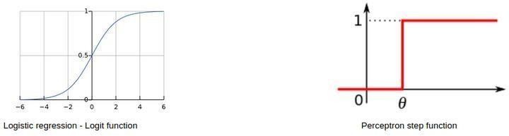

- Canwehavethesamebiasforallneuronsofahiddenlayer?

Essentially,youcanhaveadifferentbiasvalueateachlayerorateachneuronaswell.However,itis best ifwe have a bias matrix for all the neuronsinthe hidden layersaswell.

Apointtonoteisthatboththesestrategieswouldgiveyouverydifferentresults.

- Whatifwedonotuseanyactivationfunction(s)inaneuralnetwork?

Themainaimofthisquestionistounderstandwhyweneedactivationfunctionsinaneuralnetwork.You can start off bygivinga simple explanation of how neural networksare built:

Step1:Calculate the sumofall the inputs (X)accordingtotheirweights andinclude the bias term:

Z=(weights*X)+ bias

Step2:Applyanactivationfunctiontocalculatetheexpectedoutput:Y= Activation(Z)
Steps1and2areperformedateachlayer.Ifyourecollect,thisisnothingbutforwardpropagation! Now, what if there is no activation function?
OurequationforYessentiallybecomes:

Y=Z=(weights*X)+bias

Wait – isn’t this just a simple linear equation? Yes – and that is why we need activation functions. A linear equationwillnot be able to capturethe complexpatterns inthe data –this is even more evident in the case ofdeep learning problems.

Inordertocapturenon-linearrelationships,weuseactivationfunctions,andthatiswhyaneural network without anactivation function isjust a linear regression model.

- Inaneuralnetwork,whatifalltheweightsareinitializedwiththesamevalue?

In simplest terms, ifall the neurons have the same value of weights, each hidden unit will get exactly the same signal. While this might work during forward propagation, the derivative of the cost function during backward propagation would be the same everytime.

In short, there is no learning happening by the network! What do you call the phenomenon of the model beingunableto learnany patterns fromthe data? Yes, under fitting.

Therefore,ifallweightshavethesameinitialvalue,thiswouldleadtounderfitting.

- What istheroleofweightsandbiasinaneuralnetwork?

This is a question best explained with a real-life example. Consider that you want to go out today to play a cricket match with your friends. Now, a number of factors can affect your decision-making, like:

  - Howmanyofyourfriendscanmakeittothegame?
  - Howmuchequipmentcanallofyoubring?
  - Whatisthetemperatureoutside?
Andso on.These factorscanchange yourdecisiongreatlyornottoo much.Forexample, ifit is rainingoutside,thenyoucannotgoouttoplayatall.Orifyouhaveonlyonebat,youcanshareitwhile playing aswell. The magnitude bywhichthese factorscanaffect the game iscalled the weight of that factor.

Factors like the weather or temperature might have a higher weight, and other factors like equipment would have a lower weight.

However, does this mean that we can play a cricket match with only one bat? No – we would need1 balland6 wicketsas well.Thisiswherebias comesintothepicture.Biasletsyou assign some threshold which helps you activate a decision-point (or a neuron) only when that threshold is crossed.
PROGRAM10(a)
Aim:BuildSVMmodelwithvariouskernelsandselectbestkernelforgivendataset.

SoftwareRequired:Google CoLab,Jupyter note book,Kaggle. Dataset:https://www.kaggle.com/datasets/uciml/human-activity-recognition-with-smartphones

About Dataset The Human Activity Recognition database was built from the recordings of 30 study participants performing activities of daily living (ADL) while carrying a waist-mounted smartphone with embedded inertial sensors. The objective is to classify activities into one of the six activities performed.
Description of experimentThe experiments have been carried out with a group of 30 volunteers within an age bracket of 19-48 years. Each person performed six activities (WALKING, WALKINGUPSTAIRS,WALKINGDOWNSTAIRS,SITTING,STANDING,LAYING)wearin
ga
smartphone(SamsungGalaxyS II)onthewaist. Usingitsembeddedaccelerometer andgyroscope, we captured 3-axial linear acceleration and 3-axial angular velocity at a constant rate of 50Hz. The experiments have been video-recorded to label the data manually. The obtained dataset has been randomlypartitioned into two sets, where 70% of the volunteers was selected for generating the training data and 30% the test data.
The sensor signals (accelerometer and gyroscope) were pre-processed by applying noise filters and then sampled in fixed-width sliding windows of 2.56 sec and 50% overlap (128 readings/window).The sensor acceleration signal, which has gravitational and body motion components, was separated using a Butterworthlow-passfilterinto body accelerationandgravity.Thegravitational force is assumed to have only low frequency components, therefore a filter with 0.3 Hz cutofffrequency was used. From each window,avector of features was obtained by calculating variables fromthetimeand frequency domain.
Attributeinformation
Foreachrecordinthedatasetthefollowingisprovided:
Triaxialaccelerationfromtheaccelerometer (totalacceleration)andtheestimatedbodyacceleration.TriaxialAngularvelocity from the gyroscope.
A561-featurevector withtimeandfrequencydomainvariables.Its activity label.
Anidentifierofthesubjectwhocarriedouttheexperiment.

Theory:
SupportVectorMachineor SVMis oneofthemost popularSupervisedLearningalgorithms, which is used for Classification as well as Regression problems. However, primarily, it is used for Classification problems in Machine Learning.

The goal of the SVM algorithm is to create the best line or decision boundary that can segregate n- dimensionalspaceintoclasses sothat wecan easilyput thenew data point inthecorrect categoryin the future. This best decision boundary is called a hyperplane.
SVM chooses the extreme points/vectors that help in creating the hyperplane. These extreme cases are called as support vectors, and hence algorithm is termed as Support Vector Machine. Consider the below diagram in whichthere are twodifferent categories thatareclassifiedusing a decision boundary or hyperplane:
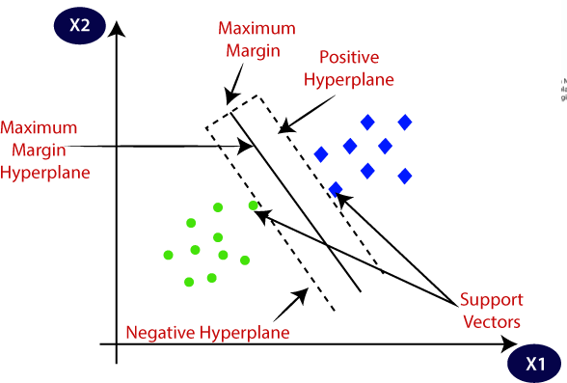

Example: SVM can be understood with the example that we have used in the KNN classifier. Suppose we see a strange cat that also has some features ofdogs, so ifwe want a modelthat canaccuratelyidentifywhether it is a cator dog, so sucha modelcanbe created by using the SVM algorithm. We will first trainour model withlotsof imagesof catsanddogs so that it canlearnabout different features of cats and dogs, and then we test it with this strange creature. So as support vector creates a decision boundary between these two data(catanddog) andchooseextremecases(supportvectors), itwillsee the extreme case of cat and dog. Onthe basis of the support vectors, it willclassify it as a cat.
Considerthebelowdiagram:
TypesofSVM SVMcanbeoftwotypes:

- Linear SVM: Linear SVM is used for linearly separable data, which means if a dataset can be classified into two classes by using asingle straight line, then such data is termed as linearly separable data, and classifier is used called as Linear SVM classifier.
- Non-linear SVM: Non-Linear SVM is used for non-linearly separated data,whichmeansifadatasetcannotbeclassifiedbyusinga
straight line, then such dataistermed asnon-linear dataand classifier used iscalled asNon-linear SVM classifier.
HyperplaneandSupportVectorsintheSVMalgorithm:

Hyperplane:Therecan bemultiplelines/decisionboundariesto segregatethe classes in n- dimensional space, but we need to find out the best decision boundarythat helps to classify the data points. This best boundary is knownas the hyperplane of SVM.

Thedimensionsofthehyperplanedependonthefeaturespresentinthe dataset, which
meansifthereare2features(asshowninimage),thenhyperplanewillbeastraightli ne.
Andifthereare3features,thenhyperplanewillbea2-dimensionplane.

We always create a hyperplane that has a maximum margin, which meansthe maximum distance between the data points.
SupportVectors:

The data points or vectors that are the closest to the hyperplane and which affect the position of the hyperplane are termed as Support Vector. Since these vectors support the hyperplane, hence called a Support vector.

Program:

#Import required basic libraries importnumpyasnp#linearalgebra
importpandasaspd#dataprocessing,CSVfileI/O(e.g.pd.read_csv)importos

# Read dataset into dataframe data=pd.read_csv('/kaggle/input/human-activity-recognition-with- smartphones/train.csv')
data.describe() data

data.info() data.columns
data.Activity.value_counts() data.shape
data['activity_code']=data.Activity.astype('category').cat.codes data.shape data.activity_code

data1=data.drop('Activity',axis=1) data1.shape
x_col=data1.columns.to_list() x_col.pop(-1) x_data=data1[x_col] y_col='activity_code'
fromsklearn.model_selectionimporttrain_test_split train_x,test_x,train_y,test_y=train_test_split(data1[x_col],data1[y_col].values,te st_size=0.1)
train_x.shape,test_x.shape,train_y.shape,test_y.shape test_y
#TrytobuildLogisticregression fromsklearn.linear_modelimportLogisticRegression from sklearn.metrics import accuracy_score lg=LogisticRegression()#max_iter=800,solver='sag') lg.fit(train_x,train_y)train_y_pred=lg.predict(train_x) test_y_pred=lg.predict(test_x) #
print("TrainingAccuracy",accuracy_score(train_y,train_y_pred)) print("Testing Accuracy", accuracy_score(test_y,test_y_pred))

fromsklearn.metricsimportconfusion_matrix confusion_matrix(train_y,train_y_pred)

confusion_matrix(test_y,test_y_pred)

SupportVectorClassifier:
SVC(*, C=1.0, kernel="rbf", degree=3, gamma="scale", coef0=0.0, shrinking=True, probability=False, tol=1e-3, cache_size=200, class_weight=None, verbose=False, max_iter=-1, decision_function_shape="ovr", break_ties=False, random_state=None)

Parameters
C: float, default=1.0 Regularization parameter. The strength of the regularization is inversely proportional to C. Must be strictly positive. The penalty is a squared l2 penalty.
kernel : {'linear', 'poly', 'rbf', 'sigmoid', 'precomputed'} or callable, default='rbf'Specifiesthekerneltypetobeusedinthealgorithm.Ifnone isgiven, 'rbf' will be used. If a callableisgiven itisused to pre- computethekernelmatrixfromdatamatrices;thatmatrixshouldbeanarrayof shape (n_samples, n_samples).
degree:int,default=3Degreeofthepolynomialkernelfunction('poly'). Ignored by all other kernels.
gamma:{'scale','auto'}orfloat,default='scale'Kernelcoefficientfor'rbf','poly'and'sigmoid'.
coef0:float,default=0.0Independentterminkernelfunction.Itisonly significant in 'poly' and 'sigmoid'. shrinking:bool,default=TrueWhethertousetheshrinkingheuristic.Seethe:ref:UserGuide
<shrinking_svm>.
probability:bool,default=FalseWhethertoenableprobabilityestimates. This must be enabled priortocalling fit,willslowdownthatmethodasitinternallyuses5-foldcross-validation, andpredict_probamaybeinconsistentwithpredict.Readmoreinthe:ref:UserGui de
<scores_probabilities>.
tol:float,default=1e-3Toleranceforstoppingcriterion. cache_size:float,default=200Specifythesizeofthekernelcache(inMB). class_weight:dictor'balanced',default=NoneSettheparameterCofclassi toclass_weight[i]*CforSVC.Ifnotgiven,allclassesaresupposed to haveweight one. The "balanced" mode usesthe values of y to automatically adjust weights inversely proportional to class frequencies in the input dataas n_samples / (n_classes * np.bincount(y)).
verbose: bool, default=False Enable verbose output. Note that this setting takes advantage of a per-process runtime setting in libsvm that, if enabled, may not work properly in a multithreaded context.
max_iter:int,default=-1Hardlimitoniterationswithinsolver,or-1fornolimit.
decision_function_shape: {'ovo', 'ovr'}, default='ovr' Whether to return a one-vs-rest ('ovr') decision function of shape (n_samples, n_classes) as all other classifiers, or the original one-vs- one('ovo')decisionfunctionoflibsvmwhichhasshape(n_samples,n_classes*(n_ classes-1)/
2). However, one-vs-one ('ovo') is always used as multi-class strategy. The parameter is ignored for binary classification.
break_ties: bool, default=False If true, decision_function_shape='ovr', and number of
classes>2,:term:predictwillbreaktiesaccordingtotheconfidencevaluesof
:term:decision_function; otherwise the first class among the tied classes is returned. Please note that breaking tiescomesat a relatively high computational cost comparedto a simple predict.
random_state: int, RandomState instance or None, default=None Controls the pseudo random numbergenerationfor shuffling the data for probability estimates. Ignored when probabilityis False.Passanintforreproducibleoutputacrossmultiplefunctioncalls.See:term:G lossary
<random_state>.

#BuildSVMmodelusingsvm.SVCwithdefaultparameters.Defaultkernelisrbl from sklearn.svm import SVCsv=SVC()#defaultkernelis'rbl'sv.fit(tra
in_x,train_y) train_y_pred=sv.predict(train_x) test_y_pred= sv.predict(test_x) #
print("TrainingAccuracy",accuracy_score(train_y,train_y_pred)) print("Testing Accuracy", accuracy_score(test_y,test_y_pred))

#BuildSVMmodelusingsvm.SVCwithLinearKernelfrom sklearn.svm import SVC sv=SVC(kernel='linear') sv.fit(train_x,train_y)
train_y_pred=sv.predict(train_x) test_y_pred=sv.predict(test_x)#
print("TrainingAccuracy",accuracy_score(train_y,train_y_pred)) print("Testing Accuracy", accuracy_score(test_y,test_y_pred))
# BuildSVMmodelusingsvm.SVCwithPolynomialkernel from sklearn.svm import SVC
sv=SVC(kernel='poly') sv.fit(train_x,train_y) train_y_pred=sv.predict(train_x) test_y_pred=sv.predict(test_x)#
print("TrainingAccuracy",accuracy_score(train_y,train_y_pred)) print("Testing Accuracy", accuracy_score(test_y,test_y_pred))

#BuildSVMmodelusingsvm.SVCwithSigmoidkernel from sklearn.svm import SVC sv=SVC(kernel='sigmoid') sv.fit(train_x,train_y)
train_y_pred=sv.predict(train_x) test_y_pred= sv.predict(test_x)

#
print("TrainingAccuracy",accuracy_score(train_y,train_y_pr ed)) print("Testing Accuracy", accuracy_score(test_y,test_y_pred))
#
BuildSVMmodelusingsvm.SVCwithSigmoidkernelandgamm aasaut o
from sklearn.svm
import SVC
sv=SVC(kernel='sigmoi d',gamma='auto') sv.fit(train_x,train_y) train_y_pred=sv.predict (train_x) test_y_pred= sv.predict(test_x)
#
print("TrainingAccuracy",accuracy_score(train_y,train_y_pr ed)) print("Testing Accuracy", accuracy_score(test_y,test_y_pred))
RESULT:

TrainingAccuracyofSVCwithoutKernelis0.95525997581 62031 Testing Accuracy of RFC without Kernel is0.9497282608695652

TrainingAccuracyofSVCwithlinearKernelis0.9936 517533252721 Testing Accuracy of SCV with linear Kernel is0.9836956521739131

TrainingAccuracyofSVCwithpolyKernel0.9578295 042321644 Testing Accuracy of SVC with Poly Kernel 0.9565217391304348
TrainingAccuracyofSVCwithsigmoidKernel 0.3636638452237001TestingAccuracyofSVC with sigmoid Kernel 0.3451086956521739

TrainingAccuracyofSVCwithsigmoidKernel andgammaautois 0.3659310761789601 TestingAccuracyofSVC withsigmoidKernel andgammaautois 0.3464673913043

10.(b)ImplementClassificationonasampledatasetusingSVM?
SourceCode:
importnumpyasnp
fromsklearn.datasets import make_classification fromsklearn.model_selectionimporttrain_test_split fromsklearn.svm import SVC
fromsklearn.metricsimportaccuracy_score,classification_report

#Generateasampledataset X, y = make_classification(
n_samples=200,#Numberofsamples n_features=2,# Number of features n_classes=2, # Number of classes n_informative=2,
n_redundant=0,
random_state=42
)

#Splitthedataintotrainingandtestingsets
X_train, X_test, y_train, y_test = train_test_split(X, y, test_size=0.3, random_state=42)

#CreateanSVMmodel
svm_model=SVC(kernel='linear',random_state=42)

# Train the model svm_model.fit(X_train,y_train)

#Make predictions
y_pred=svm_model.predict(X_test)

#Evaluatethe model
accuracy = accuracy_score(y_test, y_pred) report=classification_report(y_test,y_pred)

#Print results
print(f"Accuracy:{accuracy*100:.2f}%") print("\nClassification Report:\n")
print(report)

#Visualizethedecisionboundary(optional)
importmatplotlib.pyplotasplt

defplot_decision_boundary(X,y,model):
x_min,x_max=X[:,0].min()-1,X[:,0].max()+1
y_min,y_max=X[:,1].min()-1,X[:,1].max()+1
xx,yy=np.meshgrid(np.arange(x_min,x_max,0.01), np.arange(y_min, y_max, 0.01))
Z=model.predict(np.c_[xx.ravel(),yy.ravel()]) Z = Z.reshape(xx.shape)
plt.contourf(xx, yy, Z, alpha=0.8, cmap=plt.cm.coolwarm) plt.scatter(X[:,0],X[:,1],c=y,edgecolors='k',cmap=plt.cm.coolwarm) plt.title("SVM Decision Boundary")
plt.xlabel("Feature1")
plt.ylabel("Feature2") plt.show()

# Plot decision boundary plot_decision_boundary(X_test,y_test,svm_model)

SampleOutput
Youwillseeanoutputlikethis: markdown
Copy Edit Accuracy:95.00%

ClassificationReport:

support | precision | recall | f1-score
0  31 | 0.95 | 0.95 | 0.95
1  29 | 0.94 | 0.94 | 0.94

accuracy 0.95 60
macroavg 0.95 0.95 0.95 60
weightedavg 0.95 0.95 0.95 60

